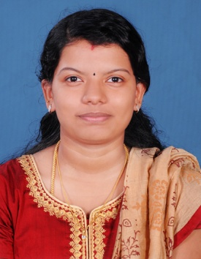

Saranya
Saranya.371589@2freemail.com
Electrical Engineer

Career Objective

Seeking a challenging and rewarding opportunity with an organization of repute which recognizes and utilizes my true potential while nurturing my analytical and technical skills
Experience

- Working as sub station operator in KSEB (Government Sector) in 66kV substation Thodupuzha, Kerala, India . From 2013 December to 2016 January.
- Working as sub station operator in KSEB (Government Sector) in 33kV sub station Paika, Kerala, India. From 2016 May to 2017 July.
Summary of Skills

- Course Completed in AMIE in Electrical Engineering, managing day-to-day operational aspects of projects by effectively applying methodologies that enforce project standards and minimize exposure and risks on projects.
- Accented with the latest trends and techniques of the field, having an inborn quantitative aptitude & determined to carve a successful and satisfying career.
- Self-motivated, hardworking and goal-oriented with a high degree of flexibility, creativity, resourcefulness, commitment and optimism.
- Good communication skills, verbal as well as written coupled with exceptional presentation skills with the ability to perform above expectations.
- An effective team player with good planning and execution skills coupled with a systematic approach and quick adaptability.
Educational Credentials

Electrical Engineering - 2013

- (AMIE) Visvewaraya College of Engineering, Mattakara, Kottayam, Kerala.

Higher Secondary School - 2009

- NSS Higher Secondary School, Kidanoor, Kottayam, Kerala, HSE.

Academic Project

- Manufacturing, Testing and Maintenance of 500 KVA 11 KV/433V Cast Resign Type Distribution Transformers.

Training

- Certification in AutoCAD.
- Training in Uni power transformer Pvt.Ltd. Nelladu, Eranakulam, Kerala, India for a month.

Software Skills

- AutoCAD 2D
- Electrical AutoCAD 2D(Autodesk certification)
- Utilities: Ms Office
- Operating System : Microsoft Windows
- Knowledge : Internet.
Achievements

- Currently managing entire Electrical Sub – Station for a locality in the District of Kottayam, Kerala, India.
- Program coordinator Cultural Events in College.
- Member and active participant of National Service Scheme (NSS).
- Active Member of IEEE activities during college.
- Participation in Inter College technical and cultural fests
- Prizes in various quiz competitions in School and College level.

Languages Known

Reading and Writing Skills in English, Hindi and Malayalam.

Reference

Will be submitted on request.

