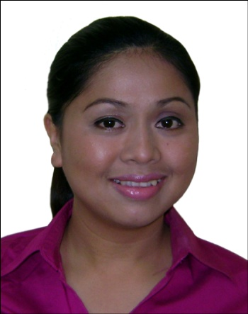
RAQUEL

RAQUEL.371609@2freemail.com

Summary of Qualifications:
    - Provide consistent high quality service and accurate information to customers. Goal-oriented and dynamic.
    - Five (5) years of extensive experience in Call Center Industry as a Customer Service Representative.
    - Great knowledge of office practices and procedures; business correspondence.
    - Well versed in Microsoft Office, internet look-up, and up to date procedures relating to technology. Galaxy system trained.
    - English proficiency, strong interpersonal skills and excellent organizational skills.

WORK EXPERIENCE

- January 26, 2011-July 31,2015
ICELAND WATER PARK
Polo RAK Amusements LLC
Ras Al Khaimah, UAE

Guest Relations - Sr. Team Leader

- Allocating task to each team members.
- Ensuring the performance of each team member is of a high standard.
- Monitor each team member’s break time schedules.
- Relieve the team members if needed.
- Cascade important information to the team members regarding management policies, promotions and other work related information.
- Assist the guests’ inquiry.
- Attend to guest complaints and forward complaints to the concerned department.
- Report to the Manager regarding the issues on any particular day.
- Responsible in coordinating group bookings to the concerned departments.
- Handling opening and closing briefing to update the team members.
- Monitor the area covered by the guest relations department.
- Respond to emails received.
- Prepares the daily attendance of each team members and submit the updated record to Human Resources.
- Discussing and resolving problems.
- Prepares SOP for the team.
- Prepares checklist for each team members.

HR Executive

- Assists and answers questions and inquiries as reception for the Human Resources Office –in person and over the phone or through email.
- Maintaining employee files and the HR filing system.
- Provides job candidates by screening, interviewing, and testing applicants; notifying existing staff of internal opportunities; maintaining personnel records; obtaining temporary staff from agencies.
- Maintains human resources records by recording new hires, transfers, terminations, changes in job classifications, merit increases; tracking vacation, sick, and personal time.
- Orients new employees by providing orientation information packets; reviewing company policies; gathering withholding and other payroll information; explaining and obtaining signatures for benefit programs.
- Log-in to paytrax for each colleagues’ leave applications.
- Supports the operations during busy time like EID Holidays and any other special events as well as during Ladies Night.

GUEST RELATIONS EXECUTIVE

- Attends promptly to customers' inquiries and assists them with their needs
- To furnish guests on information about the product and services of the company.
- To handle complaints and feedback of guests then provides solutions to their issues or concerns.
- Handled responsibilities of attending over the phone or through email inquiries regarding the tie up promotion with the hotel.
- Sends quotations to the guests regarding the promo
- Sends accommodation request to the Hotel Reservations Team.
- Giving confirmations to the guests regarding their room reservation through email or over the phone.
- Receives payments and submit cash summary report.
- Prepared daily front office report and send it thru email to the respective departments.

- March 2005 – February 2010 I-Contacts Corporation – A Subsidiary of Smart Quezon Avenue, Quezon City, Manila, Philippines
Customer Service Representative
- Responsible in handling over the phone sales, after sales transactions, inquiries and complaints of subscribers.
- Cross-selling new products and services.
- Coordinates with internal departments such as Complaints Management Group, Wireless Centers, Credit & Collection, Technical department and others.

- May 2002 – January 2005
Jollibee Food Corporation
BBB Branch Caloocan City, Manila, Philippines

Administrative Assistant
- Responsible in handling store funds including petty cash fund and the daily sales of store.
- Responsible in taking all banking transactions.
- Do all payroll accounts of crews and coordinating it with Head Office
- Processed all the necessary documents for each branch employees.
- Monitored store and employees’ supplies.

- February 1999 – March 2002
Starpack Corporation
Mandaluyong, Manila, Philippines

Sales Secretary - Sales/Mktg. Dept.
- Responsible in taking over the phone transactions like follow-ups from the clients.
- Send quotations to the clients regarding proposals from our Sales Representative.
- Make presentations readily available for the meetings.
- Responsible in filing monthly reports.
- Monthly inventory for office supplies
- Assisted the Sales Representatives in their paper works
- Organized their calendar schedules for appointments, meeting or client calls

EDUCATION:
Bachelor of Science in Business Administration Major in Management
Philippine School of Business Administration
Manila, Philippines
June 1995 – October 1998
Associate in Computer Science
Tiburcio Tancinco Memorial Institute and Technology
1993 - 1995

PERSONAL DATA:
Date of Birth: March 29, 1977
Gender: Female
Civil Status: Married
Nationality: Filipino

