Name: CRISTOPHER
CRISTOPHER.371610@2freemail.com

Date
Dear Madam. /Sir.
I am applying for the job of cook in your Company.
I have been working in the culinary industry for three years. For the past three years, I have served as a short-order cook. I am therefore comfortable preparing meals quickly and efficiently - a necessary skill in a busy hotel cafeteria.
I have also served in other capacities in restaurants; I began as a dishwasher, and then spent three years as a line cook at restaurant. I would be comfortable performing a variety of tasks in the hotel cafeteria.
You state that applicants should have strong customer service skills. As a short-order cook, I constantly interact with customers; I serve customers seated at the bar, and know how to maintain a positive report with customers.
I am confident that my experience and skills will make me a valuable member for any Hospitality & culinary team. I have enclosed my resume and you can call me. Thank you so much for your time and consideration.
Sincerely,
CRISTOPHER
CRISTOPHER
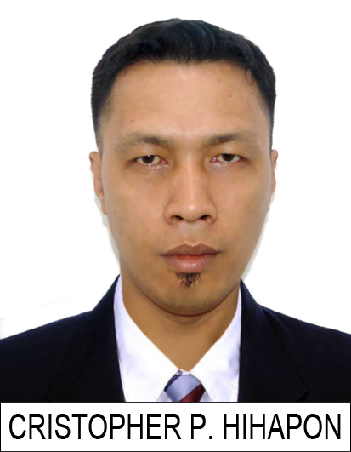

STRENGTHS:
- Excellent communications and Interpersonal skills.
- Organized and detail oriented.
- Prioritizing tasks.
- Self-motivated and quick learner.
- Astute in handling Secretarial Administrative functions.
Profile Summary

Dedicated and energetic Line Cook with a
Stellar customer service record and an
Exceptionally good attitude. Adept at
Multitasking in a high-volume Fast-paced
Work environment. Able to maintain cordial
And professional working relationships
With other staff supervisors and customers.
Education

Hotel Restaurant-Management
Datamex Colleges of the Philippines / Year: 1999-2000
Career Progression

PEARL GARDEN HOTEL March 2013 to Present
Position: line cook
Duties and responsibilities

- Inspect received raw materials such as fruit, vegetables and meat for both quality and quantity
- Ascertain that received materials are stored and inventoried according to the protocols of the company
- Cut, chop and marinate food items such as meats and vegetables so that they can be used in cooking
- Prepare soups and salads according to specific instructions provided by the chef
- Assist chef in creating dishes off the menu by ensuring that ingredients are properly measured
- Oversee cooking activities in the event of the chef’s absence
- Mix ingredients such as batter for cakes and waffles and ensure that leftovers are stored for later
- Perform proper food rotation services to keep raw food items from spoiling
- Portion and arrange food items aesthetically on dishes and platters and ensure that each order is followed up so that it is delivered on time
- Clean and maintain kitchen equipment such as grills, fryers and ovens as part of preventative maintenance programs
KEY ACCOMPLISHMENTS

- Introduced a series of quality assurance steps which increased food quality by 58%
- Implemented a food rotation system which reduced food spoilage by 85%
- Trained 15 line cooks in cake decoration techniques, with special focus on the popular fondant art

Malvar Restaurant (Philippines) May 01 2011-February 11 2013
Position: Assistant cook
Duties and responsibilities

- Assisted with preparation of cooking menu items
- Ensures that all sanitation rules are observed by the kitchen staff
- Maintained kitchen equipment and utensils
- Checked all items to ensure adequacy and quality
- Completed utility jobs as and when required
- Prepared salads, dressings and desserts
- Tested new recipes for quality and taste
- Maintain records of prepared food and manage inventory

SM Sanlazaro
Position: Sales Representative Date: From 2009 to 2010
Duties and responsibilities:

- Greeting customers who enter the shop
- Be involved in stock control and management.
- Assisting shoppers to find the goods and products they are looking for.
- Being responsible for processing cash and card payments.
- Stocking shelves with merchandise.
- Answering queries from customers.
- Reporting discrepancies and problems to the supervisor.
- Giving advice and guidance on product selection to customers.
- Balancing cash registers with receipts.
- Dealing with customer refunds.
- Keeping the store tidy and clean, this includes hovering and mopping.
- Responsible dealing with customer complaints.
- Working within established guidelines, particularly with brands.
- Attaching price tags to merchandise on the shop floor.
- Responsible for security within the store and being on the lookout for shoplifters and fraudulent credit cards etc.
- Receiving and storing the delivery of large amounts of stock
- Keeping up to date with special promotions and putting up displays.

Grand Prix Hotel – Philippines Date: 2008- 2009
Position: Waiter Food Handler
Duties and responsibilities:

Responsible for serving foods and beverage to the guest according to service procedures in order to acquire and maintain customers.
- To provide personalized, courteous and friendly service that exceeds expectation to establish hotel.
- Maintain the cleanliness of the area that may assign.
- To clear and set up the table
- To settle the bill of the guest
- Attend the customer of daily special items
- Explain neatly how different menu items are made describing the cooking methods and ingredients
- Welcoming the guest and to provide friendly assistance to each every guest and to anticipate customers’ needs and wants.
- Provides fast service and work with a true spirit as a team member. Manage customer’s expectations towards the satisfaction of quality service. Handling minimal guest complaints, responsibilities take immediate actions.
- Have all the knowledge of all menus & beverages.
- Attends the daily briefing and to be aware of all special promotions.
- Motivate and trained a newly hired team player.
- Thanking the guest for repeated visit

Personal Details

Gender: Male Civil Status: Married
Language: English, Tagalog Nationality: Filipino
Date of Birth: Nov 01, 1979 Place of Birth: Navotas City Manila

