ANOOJA

ANOOJA.371623@2freemail.com

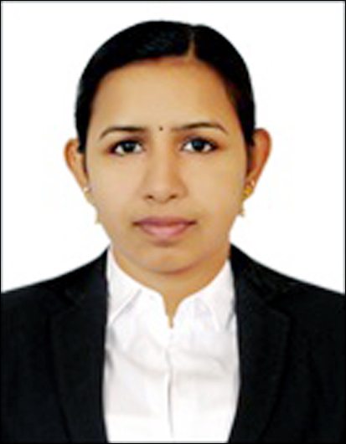

Personal Information:

Sex: Female
Date of Birth: 12-03-1994
Nationality: Indian

Language Known:
English, Hindi, Tamil and Malayalam

Visa Status:
Husband Visa
Validity: till 04th Jan 2019

Career Objective:

To be associated with a progressive organization which can provide me with a dynamic work sphere to extract my inherent skills as a professional, use and develop my aptitude to further the organization’s objectives and also attain my career targets in the progress.

Professional Skills:

- Excellent interpersonal and communication skills.
- Highly motivated individual with abilities to prioritize work and to meet deadlines.
- Aptitude to communicate logically & ability to identify and overcome objections.
- Experience in motivating and fostering team environment.
Maintain positive attitude in the face of changes in work assignments.
- Punctuality time management capability.
- Can work efficiently in a group as well as an individual.
- Conceptually strong with an innovative, detail-oriented and analytical approach to the work.
      - Self-motivated, hardworking and goal-oriented with a high degree of flexibility, creativity and commitment.

Academic Credentials:

- BCom (Co-Operation) : (2011- 2014)
Pragathi Vidya Niketan
Kannur University

- Plus Two ( Commerce ) : ( 2009-2011)

Work Experience

- Accounts Executive – Graphikking (Kannur, Kerala, India)
(2015 – 2016)

Roles & Responsibilities:
- Serve visitors by greeting, welcoming directing them appropriately.
- Answer, screen and forward any incoming phone calls while providing basic information when needed.
- Providing quotations and rates on the basis of customer requests.
- Receive and sort daily mails / deliveries / couriers.
- Receiving and solving customer complaints.
- Update appointment calender and schedule meetings / appointments.
- Receiving, Verifying and booking of supplier invoices.
- Preparation of Accounts Statements
- Preparing Bank reconciliation statements on weekly basis.
- Maintaining petty cash account and distributing cash for day to day activities.
- Providing various sales and financial reports to management.
- Issue of invoice & Credit notes with proper approval of management.
- Printing and Distribution of cheques.
- Routine payment follow up with customers.
- Proper management of documents & Customer records.

Area of Expertise:

- Advanced Skills in Microsoft Excel.
- Efficiency in Computerised Accounting (Tally ERP 9, Peachtree)
- Efficiency in MS Office (Word, Excel, PowerPoint)
- Typewriting (40 wpm)
- Data Analysis & Interpretation.
- General Administration
- Customer service expertise.

Professional Certificates:

- DCFM in 2015 from Jyothirgamaya Computer Education (C-Dit CEP, Under GOVT of Kerala).
- Tally in 2014 from Wais Computer Academy (Kannur, Kerala).
- Certification on Data entry operating.
- Certification on Business Excel.

Declaration:
I hereby declare that the above mentioned information is correct and very much sincere as knowledge.

