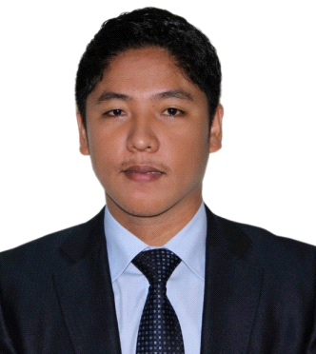

LYMAR
LYMAR.371637@2freemail.com

CAREER OBJECTIVE:
Seeking for a job where I can use my practices in operating machinery, production operations and customer care learned so far to increase the operational efficiency of the company.

WORK EXPERIENCE:

Position: PRODUCTION/MACHINE OPERATOR (August 2012 – to present)
Company: ECO Filters FZCO, South 1 Jebel Ali Free Zone Authority, Dubai UAE

Duties and Responsibilities

- Operates 7 kinds of Machines such as, Folds and Sealed machine, Hot Knife, Pressing machine, Filter cutting machine, Champer cutting machine, Drilling machine and Fabric cutting machine.
- Set up machines at the beginning of shift to ensure proper working order
- Perform testing procedures to ensure that machines work optimally during the production procedures
- Maintain and clean machines before and after each shift
- Perform random tests to ensure accuracy
- Perform safety checks on every machine
- Ensure stocks of needed materials are ready and available at all times
- Provide relevant information regarding progress to supervisors
Position: Warehouse Personnel/Store Keeper (April 2010 – July 2012)
Company: Smart Move Packaging Services, Dubai UAE

Duties and Responsibilities

- Ensure that machinery is set up correctly and to standard
- Move raw materials to the production areas and finished products to the storage areas.
- Create a production schedule for packaging and shipping
- Load containers onto forklifts and drive them to the delivery pallet
- Monitor packaging and warehouse operations
- Ensure quality control processes are completed
- Maintain the warehouse and packaging production line
- Ensure that line changeover duties are performed in a timely manner.
SKILLS
- Strong people management and leadership skill.
- Ability to motivate co-workers
- Strong communication skills (verbal and written)
- A strong work ethic and hands-on approach

EDUCATIONAL BACKGROUND:

College: Heavy Equipment Operation
Technical Course (Graduate 2004)
Boling Technical Institute
Alaminos City, Philippines

PERSONAL INFORMATION:

Age: 32 years old
Birth date: June 4, 1985
Civil Status: Married
Nationality: Filipino
Language Spoken: Filipino and English
Gender: Male
Religion: Roman Catholic
Height: 5’7”
Visa Status: Employment Visa (Freezone)

