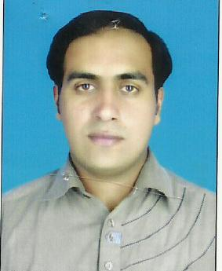
SAAD
SAAD.371662@2freemail.com
OBJECTIVE:
To work with the best of my capabilities for the achievement of organizational objectives and excel in a professional conductive and challenging environment.

PERSONAL DETAILS

Date of Birth : 12-04-1989
Gender : Male
Religion : Islam
Marital Status : Married
ACADEMIC QUALIFICATION
Education | Board/University | Year | Marks
Matric | BISE. BAHAWAL PUR | 2005 | 426/850
F.A | BISE. Karachi | 2008 | 729/1100
B.A | UNIVERSITY OF KARACHI | 2012 | 617/1000

COMPUTER SKILLS:
- MS Office (word, excel, power point etc)
- Languages:
- English Urdu
Experience
3 year experience as Data entry Computer & Software Operate ( Gourmet Foods Pakistan )

2 year experience as admin office work ( Suncrop Pvt Ltd )

1 year experience as sale and Markting (Fauji Foods Limited )

