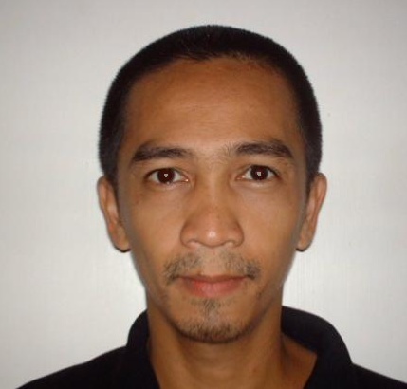
Gabriel

Gabriel.371666@2freemail.com

OBJECTIVE

To advance in any suitable position through the application and refinement of skills learned in the course of my formal education, training and work experience.

SKILLS/INTERESTS

Mechanical Engineering Graduate : PRC

Computer Literate: Windows and its applications
Proficient in Auto-CAD and Sketchup 3D

Driver’s License : Dubai Driving License (Automatic)

WORK EXPERIENCES

Nad Al Sheba Private Club
Nad Al Sheba, Dubai
April 02, 2016 - Present
Position: Principal Support
- Maintenance of facilities and equipments.
- Supervision of projects.
- Operation of the machine for racing.

Esperanto General Trading
Al Barsha, Dubai
May 16, 2015 - April 01, 2016
Position: Site Engineer
- Estimate of materials.
- Support on Design and Drawings.
- Supervision of projects.

Triple Eight Engineering
Calamba Laguna, Philippines
August 21, 2008 - December 03, 2014
Position: Mechanical Engineer
- Estimate of materials.
- Support on Design and Drawings.
- Supervision of On-going projects.

EMC Enterprises and Heavy Equipment Rentals
Calamba Laguna, Philippines
January 09, 2006 – July 30, 2008
Position : Site Engineer
- Estimate of materials.
- Support on Design and Drawings.
- Supervision of On-going projects.

Department of Public Works and Highways
VBL Infrasructure Project Management Consultancy
Project : Arterial Road Bypass Project Phase C (Plaridel/Cabanatuan)
July 05, 2005 – October 04, 2005
Position: CAD Operator
- Draws from field sketches and architectural drawings.
- Editing and printing of final drawings.

Ergonomic Systems Phils. Inc.
2634 Rockerfeller St., Makati City
May 06, 2002- March 23, 2004
Position: Design Engineer, Research and Development Dept.
- Design/Innovate products as per instruction by the product design consultant or the R&D Head or Senior Designer on products under his categories. Bill of materials included.
- Supervise prototype making of new designed items.
- Supports marketing, costing, and sales department for drawing needs and material analysis and estimates. Also assist production department for technical needs
- Conducts product research and study.
- Assists in the manualization program of products.
- Conducts initial (experimental) time and motion study for new products and develop production methods.
- In-charge of all new product design.
.

EDUCATIONAL BACKGROUND
Colegio de San Juan de Letran
Calamba City
BS Mechanical Engineering (2000)

PERSONAL DATA
Birthday : September 02, 1978
Religion : Catholic
Nationality : Filipino
Height : 5’5”
Weight : 120 lbs.

REFERENCES
Available upon request.

