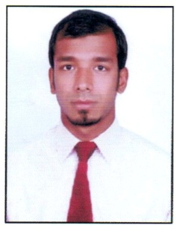
CURRICULUM VITAE

SHAIK
SHAIK.371678@2freemail.com

CAREER OBJECTIVE
To secure a challenge position in a progressive organization, where my skills can be enhanced and contribute to the organization success.

QUALIFICATION

NAME OF THE EXAMINATION | BOARD/UNIVERSITY | YEAR OF PASSING
Master Of Business Administration | Osmania University | 2015
B.Com | Osmania University | 2013
Intermediate | Board Of Intermediate | 2010
SSC | Board Of Secondary | 2008

ACADEMIC PROJECT UNDERTAKEN

A project on portfolio management and security analysis
EXPERIENCE

Working as an accountant in S.A Enterprises Pvt Ltd from Sep 2015 to June 2017
WORK RESPONSIBLITIES

- Review budgets and prepare cost report and cash flows.
- Maintain records of invoice and creditor’s payments
- Keep records of all transactions
- Prepare invoice, purchase order and petty cash
- Bank and credit cards reconciliations
- Prepare month-end and year-end reports

TECHNICAL SKILLS

- Diploma in Financial Accounting (Focus, Wings, Tally & Project in Peachtree)
- Well versed in using Emails, MS OFFICE and Internet facilities.

PERSONAL STRENGTH

- Enhance productivity and efficiency
- Adaptable to any environment
- Ability to manage task in given time

PERSONAL DETAILS

Date of Birth : 27-Mar-1992

Nationality : Indian.

Language Known : English, Hindi and Urdu

Visa status : long term visa

Valid until : 18-OCT-2017

DECLRATION

I am interested in working for your organization. I enclose my resume in exploring the possibility of employment, hope you will consider my application and give me an opportunity to show my capability.

Thanking you in anticipation of your favorable consideration.

