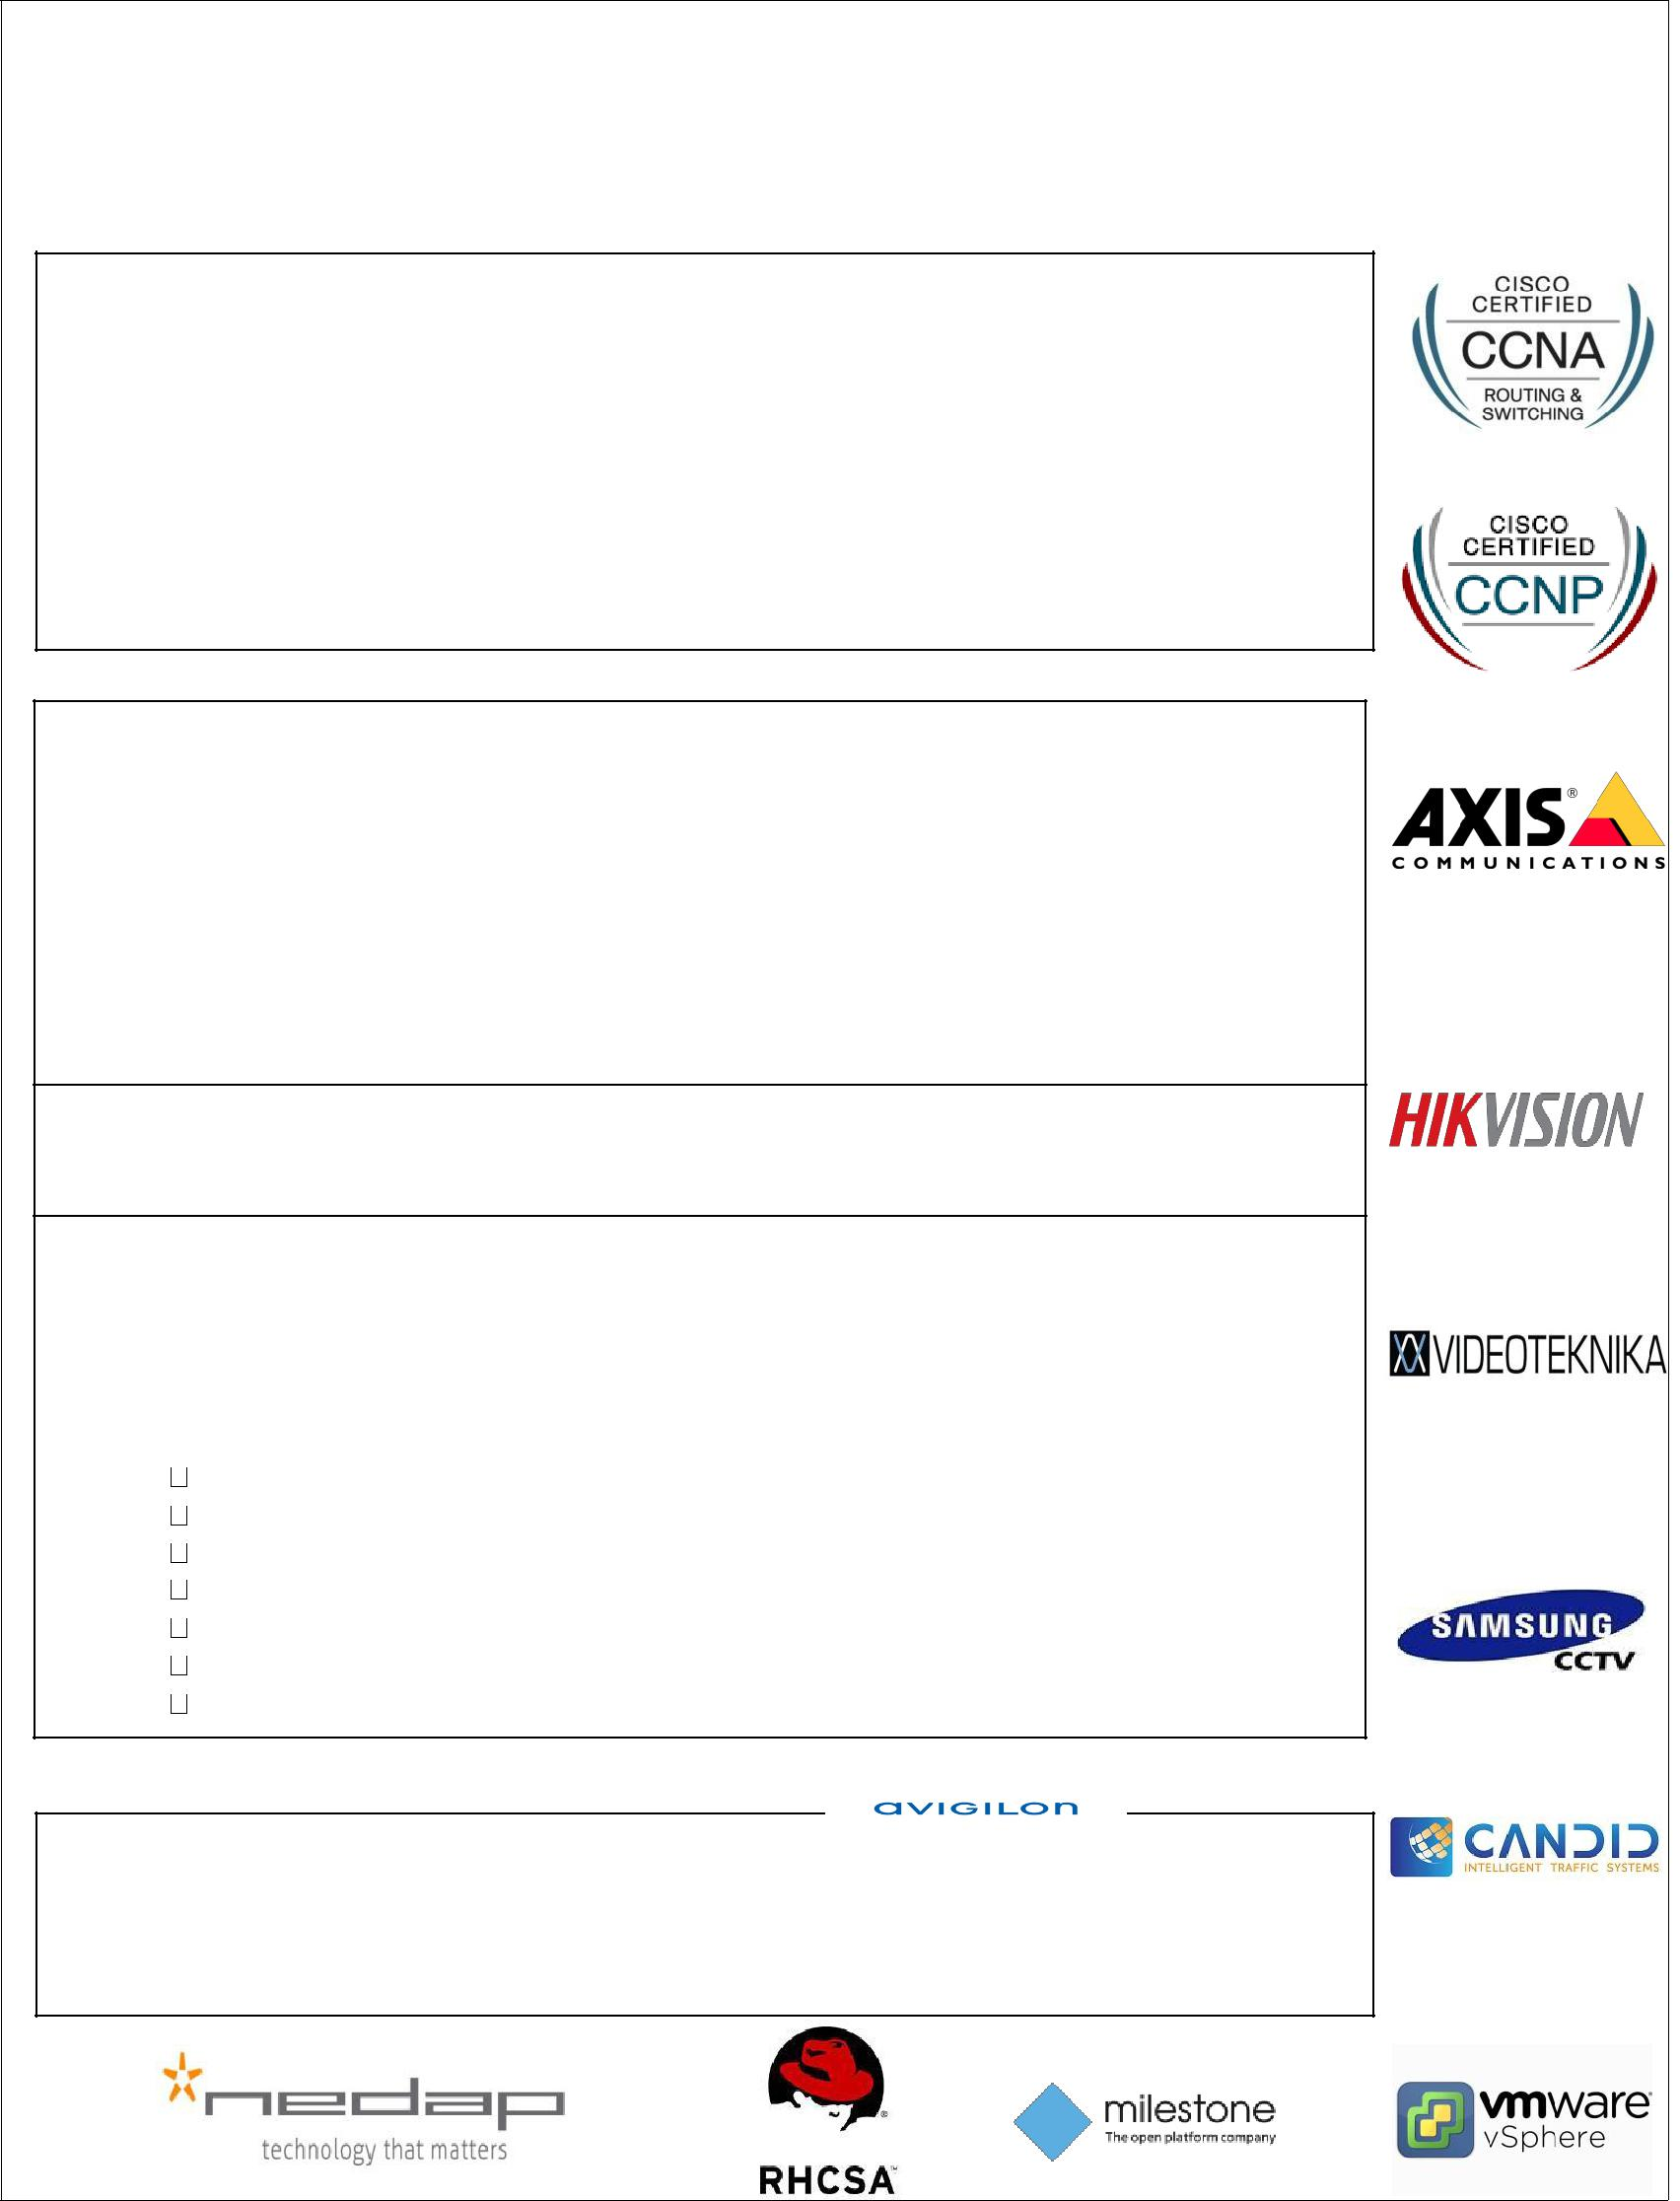
AHMED
AHMED.371682@2freemail.com

SUMMARY

Enterprising, proficient and highly qualified professional having over 7 years of Experience in the computing, data information systems and communication technologies industry. Able to confidently lead projects and work with others at all Levels of organization with dependable capacity to meet challenging deadlines through excellent time management skills and self-motivation. Also possess flexibility, Adaptability, and determination to cope with change and setbacks. I’ve been working with dependence customers: ADNOC , ADMA, AD police, Armed Forces, Ministry of Interior.

AREAS OF EXPERTISE

- CISCO CERTIFIED: Routing, Switching and network troubleshooting.

- CCTV, ACCESS CONTROL and Automatic Plate Number Recognition.

- VMWARE

- Red Hat Enterprise Linux

- KALY Linux

- Operating systems: ( LINUX Red Hat , Windows (2000, 2003, XP, Vista, windows 7 ).

- Software System Analyst

EDUCATION AND QUALIFICATION DETAILS

Diploma in Electronic Devices December 2004

- Courses:
Cisco Certified Network Associate (CCNA) 200-125 
Cisco Certified Network Professional (CCNP)300-101 
Computer Hardware maintenance and Networking analysis 
AutoCAD 2012 
Red Hat System Administrator- self study 
C++ -PHP –html – self study  
Kali LINUX- self study  
AXIS CCTV Cameras Training. 
Electrical Low Voltage  
Under processing CEH 

SKILLS AND COMPETENCES

▪ Team Leader - Trainer
▪ High communication skills - Integrity and Trust

PROFESSIONAL EXPERIENCE:

Network & System Engineer October 2014 - Present Company: Atlas Telecommunication

Responsibilities:

- Responsible for all aspects of systems administration including applications and databases.

- Monitor and manage system resources.

- Maintain system documentation and logs

- Perform and assist in troubleshooting and diagnosing production problems

- Provide technical analysis and design

- Repair and recover from hardware or software failures.

- Gave the onsite training for CANDID SEKURE for ANPR, and CCTV for ADNOC.

- Ensuring that CCTV storage, archiving procedures are functioning correctly.

- Co-ordination with different divisions for the inspections of work.

- Prepares daily activity and accomplishment report

- Configuring Routers, Switches

- Implementation & troubleshooting of LAN& WAN

- Install printers in network

- Troubleshooting the internet and pc problem

- Configuring wireless access points

- Make final inspection after completion of the work

- Managing the technical team to get the job done before time.

- Supervise the site activities in order to achieve targets at specified quality and quantity

- Installing and replacing Switches

- Configuring HP switches

- Configuring juniper firewall

- Make final inspection after completion of the work

- Structured Cabling, Crimping, Punching etc

- Configuring Routers, Switches

- Implementation & troubleshooting of LAN& WAN

- Configuration of DNS,DHCP

- Network connectivity troubleshooting, ping, tracert, telnet

- Responsible for communication protocols, configuration, integration & security.

- Investigating, troubleshooting and resolve all network problems.

- Configuring all kinds of ADSL & wireless routers.

Targets achieved:

- ADNOC CCTV SYSTEM & Automatic Number Plate Recognition systems implementation.

- ARMED FORCES NETWORK SECURITY DESIGN WITH JUNIPER FIREWALL.

- MINISTRY OF INTERIOR – CONTROL ROOM & Operation Center.

- HIGHER COLLEGES OF TECHNOLOGY CCTV SYSTEM.

- ABU DHABI POLICE CCTV INSTALLATION FOR NEW COMMUNICATION TOWER.

- ABU DHABI POLICE ( TATWEER ) LTE SMART TOWER.

- RUWAIS REFINERY CCTV SYSTEM & ACCESS CONTROL SYSTEM.

- Federal Authority for Nuclear Regulation ( FANR ) Control Room & Operation Center.

- ADMA OPCO & ADGAS CCTV SYSTEM & ACCESS CONTROL SYSTEM.

- PRESEDENTIAL PALACE TELECOM PROJECT.

PERSONAL DETAILS:
▪ | Nationality: | Egyptian
▪ | Date of birth: | 17th of January 1987
▪ | Marital Status: | Married
- No. of Dependent: 2
▪ Languages: Arabic: Native language

English: Fluent in speaking and writing

References are available upon request.

