 | NOWSATH
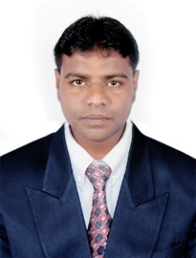 | Al-Muteena, Deira, Dubai.  United Arab Emirates.  Nowsath.371714@2freemail.com

Objectives
Seeking a challenging position in the industry where my skills and knowledge can be best utilized in adding value to organizations and in doing so, ensure my professional abilities progress to the highest levels.
Professional Profile Summary
I am a dynamic and goal driven professional who have about 1 years of experience in the information technology in areas of hardware and software.
I am an excellent team member and also able to work independently as required. I work effectively in cross cultural and multi-disciplinary teams. With excellent communication skills, written and spoken and with ability to work with all levels, I believe that I will be an asset to any organization.
Professional Experience
Computer Operator & Hardware Trainer
September 2013– September 2014

ORBIT COMPUTER EDUCATION, Thiruvarur, Tamil Nadu, India.

Responsibilities:
- Troubleshooting Problem in Network Connectivity.
- Typing Documentation, Data Entry.
- E-mail Request and Response.
- Backup files, Operating System Installation.
- Software Installation.
- Creating ID card, Visiting Card.

ACADEMIC BACKGROUND
Nethaji Subash Chandra Bose College, Thiruvarur.
2011 - 2013
MSc [cs]- Master of Science in Computer Science.

Nethaji Subash Chandra Bose College, Thiruvarur.
2008 - 2011
BSc [cs]- Bachelor of Science in Computer Science.

certification
Orbit Computer Education, Thiruvarur.
March-2012
PGDIT- Post Graduate Diploma in Information Technology.

CSC Computer Education.
July-2007 to November-2007
ADCHN- Advance Diploma in Computer Hardware and Networking.

HI-TECH Computer Centre.
July-2007 to September-2007
DDP- Diploma in Desktop Publishing.

PERSONAL PROFILE
Expansion of Initial : S.A. Haja Najubudeen,
Date of Birth : 21 February 1989,
Marital Status : Married,
Nationality : Indian,
Date of Issue : 28/11/2013,
Date of Expiry : 27/11/2023 ,
Place of Issue : Trichy,
Visa Status : Tourist,
Visa Validity : 09/09/2017.

skills
Windows Operating System, Linux, Microsoft Office Suite,
C, C++, Java, HTML, RDBMS, Adobe Page Maker.

Language Skills : English & Tamil (written & spoken)
Declaration
I hereby declared that the above furnished details are true to the best of my knowledge.

