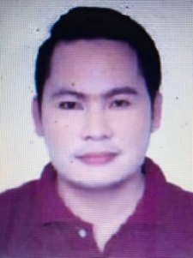
JULITO

Julito.371793@2freemail.com

_____________________________________________________________________________________

EDUCATIONAL BACKGROUND:

Bachelor of Science in Office Administration
Carcar City College
Cebu City, Philippines
Graduated: March 2015

WORK EXPERIENCE:

 Administration Assistant/ Clerk
Comelec Office and Water District Office
Carcar City, Cebu
June 01, 2016- June 30, 2017

Tasks:
1. Encodes data assigned and makes monthly report using microsoft office applications (MS Excel, Word
and Powerpoint).
2. Photocopy files assigned.
3. Maintain harmonious relationship with co-worker.
4. Assigned to generate group activities during team building.
5. Entertains customer's queries.

 Salesman of Motor Bike / Secretary
Carcar City Motorparts
Carcar City, Cebu
June 2015 - May 30, 2016

Tasks:
1. As a representative, we illustrate and explain about any kind of products manufactured by the industry
to the customers. We have to make calls and communicate with customers to sell products.
2. We have to attend customer's queries over phone and maintain e-mail to follow up contacts and sales.
3. Maintain daily and weekly report.
4. Maintains professional relationship with every customer and co-worker.
5. Attends meetings, test products, take orders and negotiate prices.

