Iftikhar
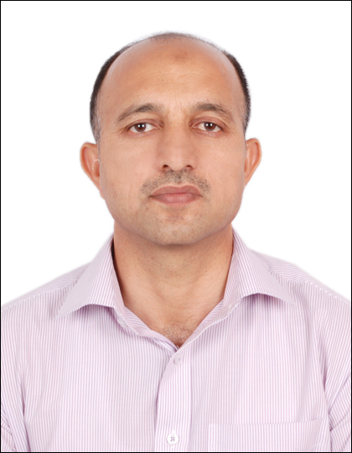
Iftikhar.371812@2freemail.com
Sales Supervisor

Personal Summary
A well-mannered articulate and conscientious retail Assistant who can communicate to customers on all levels. Smart and presentable with an ability to work as part of a team or individually to deliver and maintain a high standard of service in every aspect of a retail Shop.Possesssing the necessary enthusiasm, drive and motivation required to achieve maximum sales in a retail environment. Can communicate effectively with peoples from diverse background and would be an asset to any employer who respects, loyalty and responsibility.
Now looking for a new and challenging position, one which will make best use of my existing skills and experience and also further my career development.
Key Skills and Competencies
- Delivering Exceptional customer service.
- Having a team-oriented approach to working.
- A proven track record of driving sales.
- Excellent customer care skills.
- Track record of achieving agreed retail objectives.
- Can work efficiently and accurately in a fast paced service driven environment.
Professional Qualifications:
- Comprehensive supervisory Skill Training
- Comprehensive Customer Service Training
- Customer Complaint Handling & Telephone etiquettes.

Work Experience
Sales Supervisor Select Markets Abu Dhabi UAE
(March 2012-Till Date)
Job Responsibilities
- Approaching customers and helping them with their needs.
- Assisting the management team in maximizing the stores sales and profitability.
- Operating the till system, including cash up.
- Describing or demonstrating in detail a product and its benefits to customers.
- Assisting customers with their enquiries.
- Putting up posters and promotional materials for sales etc.
- Maintaining the cleanliness of the store all the times.
- Completing all necessary paper work at the start and end of the shift.
- Replenishing stock on shelves.
- Identify trends in complaints and highlight to the relevant Supervisor or Manager.
- Processing payments of various kinds including cash, Cheques and Credit Cards.
- Dealing politely with customers complaints and resolving them.
- Keeping the store Organized and maintaining an uncluttered environment.
- Constantly updating and replenishing sales display area.
Professional
Customer Service
Customer Service Certificate by DAS Holding in Outstanding Customer Service Programme.
Customer Service and Telephone Etiquettes: ICTD Abu Dhabi UAE
Certified in Customer Service and Telephone Etiquettes from International centre for Training and Development Abu Dhabi UAE.
Computer Skill
Six months computer certificate in Secretarial Courses (MS Office)
Academics
Degree/Cert | University/College | Year of passing | Subject
M.A | University of Peshawar | 1995 | Economics
B.A | University of Peshawar | 1993 | Statistics, Economics
F.A | BISE Peshawar | 1990 | Statistics, Economics
SSC | BISE Peshawar | 1987 | Physics,Chem,Bio,Eng

Personal Folio
Date of Birth 10th of Feb 1972
Gender Male
Marital Status: Married
Religion Islam
Visa Status: Employment
Expiry: 07/04/2018 (3rd contract)
LANGUAGES Pashto Urdu English
1st 2nd 3rd
(Fluent in all the above three languages)

Proofs will be provided upon request

