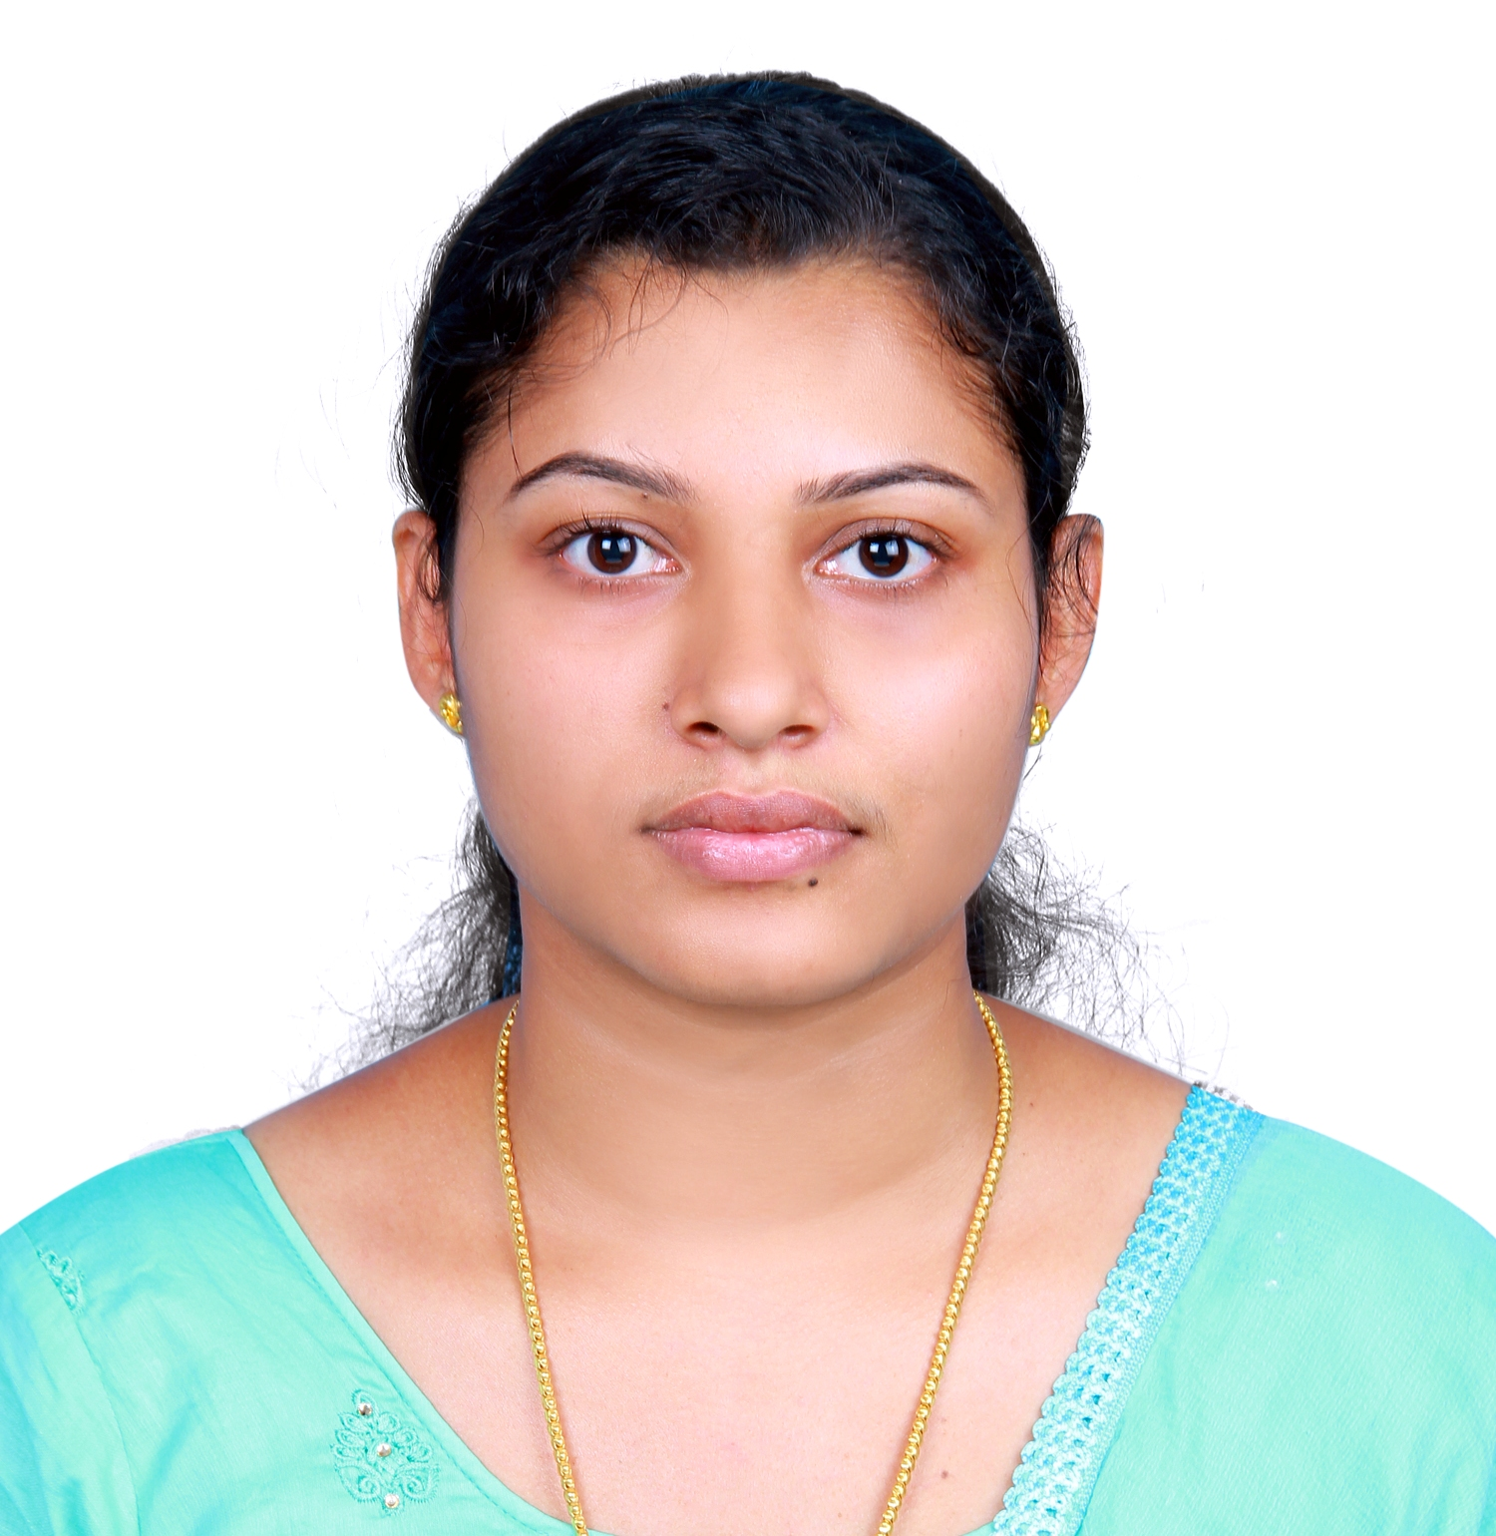

RESUME

SOUMYA

SOUMYA.371824@2freemail.com

Career Objective

To be an active part of a creative and dynamic organization, where I can utilize my skills and in the process to expand my knowledge and contribute to the development and success of the company.

Academic Qualification
Degree | University | Year | Percentage
MCA | University of Kerala | 2015 | 67%
B.Sc (Computer Science) | University of Kerala | 2012 | 68%

Experience

- 2015 – 2017: Worked as a Junior Software Developer in CODEPOINT Software PVT Ltd – Kerala, India.

  - Build PHP websites using PHP based frameworks.
  - Planned and conducted cross-browser usability testing against W3C.
  - Tested and validated work produced as part of the development process.
  - Produced detailed specifications and writing the program codes.
  - Worked with back end development and maintenance of websites.
  - Developed advanced database driven websites and systems including e-commerce.
  - Worked in a data analyst role and with business intelligence application.
  - Presented ideas for system improvements and worked closely with analysts, designers and staffs.
- Expanded and updated existing programmes.
  - Improved operations by conducting systems analysis and recommending changes in policies and procedures.
  - Serve as a subject matter expert.
  - Worked with a multi-disciplinary team to convert business needs into technical specifications.

Technical Expertise

Languages : PHP, Asp.net, Core Java, C, CPP
Web Development : HTML, CSS, JavaScript, jQuery, AJAX, AngularJS
Server Software : MySQL
Framework : Codeigniter
Office Suite : MS Word, MS Excel and Power Point
Operating System : Windows 10, Windows 7, Window 8.1
Certification

Course : Advanced PHP

Personal Skills

- Decision making and problem-solving skills.
- Excellence Communication Skills.
- Creative thinking and organizational skills.
- Quick Listener.
- Hard Working & Dedicated

Declaration

I hereby declare that the information furnished above is true to the best of my knowledge and belief.

