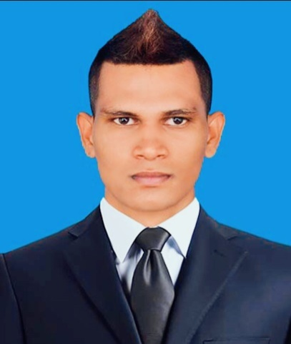
CARRICULUM VITAE
Objective: To build career in growing restaurant where
I can get the opportunities to prove my
Abilities by accepting challenges and
Fulfilling the restaurant goals and climb the
Career ladder through continues learning
And commitment.

FULL NAME:
MOHAMED

DATE OF BIRTH:
28TH OF MARCH 1991
GENDER:
MALE
Mohamed.371858@2freemail.com

NATIONALITY:
SRILANKAN
PASSPORT NUMBER:

CONTACT NUMBER:
+971551992353
EMAIL:
mohammedleen123@gmail.com

Professional summary:
gh Highly reliable and dedicated restaurant & coffee shop u worker and with a
strong customer service record and a stellar work ethic fle flexible scheduling availability t include evenings
weekends and special events as required. Able to
function well as an independent worker with little
to no supervision or as a member of a restaurant
worker team.

Background:
Chef, Waiter, Coffee Maker, Juice Maker
Pizza Maker(toast pizza),Cashier Party club , house in charge
Professional
Experience: 2014.01.10 – Doha Rocks Restaurant To (Party Club House)
2017.05.20 Doha Rocks Coffee shop
2013.03.15 – Assistant accountant in
Bank of RDD

Education: Diploma in 3D
Diploma in Auto CAD
Diploma in MEP drafting using Auto
CAD (UK-CCL)
Certificate in interior designing
Diploma in desktop applications

Extra curriculum activities:
- Successfully completed Accelerated Skills Acquisition Program – Comprehensive Curriculum (USAID) at IDM computer studies – Kalmunai.
- Successfully achieved a bronze award following E-Type (USAID) at BCS the chartered institute for IT in kalmunai.
- Successfully completed the course of Computer ApplicationAssistant (NVQ-3) at technical collage Sammanthurai – Department of technical Education & Training – Srilanka.

Computer Ability:
- Successfully completed diploma in computer application assistant
- Diploma in MS office
- Certificate Networking
- Diploma in computer hardware
- Diploma in English

Skills & Personalities:
- Excellent of prepare statements
- Good research ability
- Wants to learn other skills to develop my company
- Hard worker , pro- active & Dynamic
- Innovation & forward thinking
- Very good communication skills
- Strong interpersonal and customer service skills
- Quick & always eager to learn new technologies

I do here by certify that the above particulars given by me are true and correct to the knowledge and belief.

