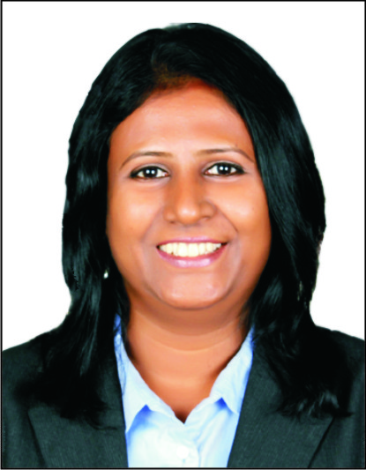

SHUBHA
SHUBHA.371877@2freemail.com

PROFESSIONAL SYNOPSIS
- Competent and versatile professional offering performance driven experience of 15 years managing the entire gamut of travel operations and client/program management of multinational clients.
- Procurement professional adept at vendor negotiations and contracting of air, hotel, car and travel agency.
- Well versed with travel management of organizations which include strategizing travel policies and implementing travel technologies.
- Experienced Project Management professional having handled various internal and external projects.
- Professional with natural flair for people management, team building, relationship enhancement & customer service
- Strong competence to create win-win relationship with internal and external stakeholders.
- Excellent team player with unsurpassed analytical skills, energy-driven motivator and optimistic individual with immense zeal and enthusiasm to accept and meet challenges in the competitive environment.
- Articulate communicator with exceptional talent for problem solving through reasoned thought processes, as attested to by a track record for employer satisfaction.
CORE COMPETENCIES
Travel Operations •Client Relationship Management •Strategic Sourcing /Procurement • Vendor / Airline Management & Negotiations•ProjectManagement •RFP•Contracting •

PROFESSIONAL EXPERIENCE AND ACCOMPLISHMENTS

CARLSON WAGONLIT TRAVEL
PROGRAM MANAGER – Since Jul 2014

- Develop a close and sustainable client relationship.
- Held complete P&L and revenue growth accountability for $45 million portfolio of a large customer.
- Developed and incorporated pricing models, customer service, and revenue growth strategies and managed receivables.
- Partner with the travel leads to manage the travel program effectively.
- Work on strategic initiatives to reduce spends on travel for clients.
- Ensure Service delivery is in line with Contractual obligations
- Ensure contingency plans are in place to manage crisis situations.
- Effective Customer Complaint Handling.
- Manage events for the client.
- RFP Management. Contract and Addendum management.
- Perform audits on service levels and work on process improvements.
- Proactively offer recommendations and perspective on client’s travel program performance.
- Involved in the invoice data capture and enhancement projects related to financials.
- MIS reports and review meetings monthly/ quarterly and yearly.
- Supplier/vendor negotiations at a strategic level.
- Negotiate and improve contract terms, pricing models and rates with all providers
- Network to be well informed with the market information.
- Implementing online booking tool and increasing the adoption of the tool.
- Update clients with regular industry updates and keep abreast with competition.
- Work on annual Business Plans and their execution.

ADOBE SYSTEMS INDIA PVT LTD
STRATEGIC SOURCING, TRAVEL- Sep 2012 to March 2014
- To understand the existing process and streamline end to end travel program
- To ensure adherence to global travel policy.
- Strategic, high level, evidence-based review of supplier performance. Setting strategic context and commitment to improvement and actions at regular period.
- Analyze, assess, and identify travel program requirements and reporting.
- Regular formal two-way communication with the account management level and operational review.
- Develop travel vendor relationships and programs such as travel agency, air, hotel, car rental and other travel related services ensuring their compliance to service level agreements and the Global Travel Policy.
- Data analysis on a regular basis to review the progress against contract, strategy/initiative formulation sessionand detailed functional review.
- Budget and Revenue management
- RFP/RFX management for hotels globally and agencies/Event Management Companies, Destination Management Companies, Corporate gifting, Marketing and other purchases related to Events.
- Conducting discussion forums and trainings on new tools/products with traveler groups.
- Conducting supplier meets .
- Continuous improvement of Traveller’s experience through monitoring/measuring and communication
- Enhance program compliance by providing visibility to leadership and management.
- Worked with the Travel management company to implement Online Booking Tool.
- Worked with Concur team in streamlining T & E processes.

HRG SITA INDIA
CLIENT MANAGER - Oct 2009 to Sep 2012

- Manage and build relationship with customers and vendors
- Profit and loss management of customers being account managed – Profit Accountability
- Vendor Negotiations and budget management for clients.
- Conducting supplier meetings.
- RFP management.
- To monitor compliance and work on the usage of preferred airline.
- Regular customer reviews
- Conduct CSAT surveys to measure level of customer satisfaction and work on feedback received with fixed timelines.
- Explore more areas of revenue with the existing customers(eg.Insurance/Forex/Leisure/Calling cards)
- Weekly/Fortnightly/Monthly reporting as per internal and external customer needs.

AMERICAN EXPRESS TRAVEL RELATED SERVICES
MANAGER – ONSITES - Jul 2007 -Jun 2009
LEAD TRAVEL COUNSELOR – BUSINESS TRAVEL UNIT – 2006 -2007
TRAVEL COUNSELOR- 2003 - 2006

- Managing a team of 16 travel counselors onsite , handling travel arrangements for 7 corporate accounts
- Instrumentally involved in recruitment and orientation of new employees on policies/processes of American Express and training.
- Audit of travel operations.
- Working on process improvisations for service delivery & sending timely reports to senior management on various audits, performance matrix, etc.
- Responsible for managing adequate staffing and ensure servicing infrastructure for frontline staff
- Actively Involved in Global Implementations of accounts and products.
- Actively involved with supplier relationship and negotiations.
- Establish & build relationships with Corporate Travel arrangers/key travelers/ decision makers in Corporate.
- Maintain Customer Complaint Log & analyze root causes for service issues, develop & implement Action Plans.
- Participate in account review.
- Received the Pacesetter Award for the year 2006 for exceptional commitment, dedication and drive shown in ensuring customer delight.

THOMAS COOK INDIA LTD
EXECUTIVE – BUSINESS TRAVEL, 2000 - 2003

- Responsible for handling complete travel arrangements for a Corporate client, preparing airline wise sales report on monthly basis & assisting client’s in visa/ passport issues.

ACADEMIC AND PROFESSIONAL CREDENTIALS
- Bachelor of Science, Bangalore University.
- DIATM, IITC Bangalore
- IATA/UFTAA Advanced Course, Geneva

- Professional Certificates :
- Galileo – Basic and Advance.
- Amadeus – Basic and Advance.
- Fares and documentation procedure for passenger sales agency - Indian Airlines

Technical Proficiency:
- Certified in Advanced excel, Well versed in MS office

PERSONAL DETAILS
Date of Birth : 30/04/78
Languages : Kannada/English/Hindi
Hobbies : Reading/Listening to music/Public Speaking

