CURRICULUM VITAE
CHINMAI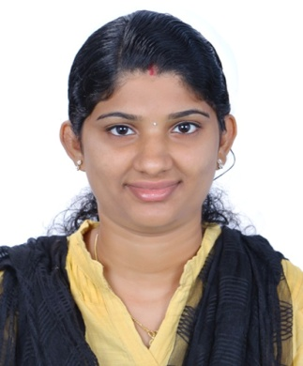

CHINMAI.371885@2freemail.com

Career objective
To chart out a career in Information Technology by taking full advantage of my specialization in computer applications and to work with my full efficiency and integrity in long term association with reputed organization.
Career Conspectus
- Masters of Computer Application from Anna University.
- Proficient in C, C++, java, .net, Sql server.
- Experience in Operating System :
Windows XP, Windows 7, Windows 8, Windows8.1, Windows10.
- Packages: MS Office, Excel, PowerPoint, Adobe Photoshop, Flash.
- Young, energetic and enthusiastic who can work under pressure and meet deadlines.
- Fast learner with an ability to excel
- Self-confident and goal oriented
EMPLOYMENT RECORD
Novae systems, Kottayam, Kerala, India
(April 2016 – May 2017)

Designation: System Administration / Computer Encoder
- Installing hardware - computers, terminals, disk drives, CD-ROMs, RAM, printers, cabling.
- Monitoring printers, disk space, network, servers and workstations, performance, and security, and all log files regularly.
- Regular preventative maintenance of computer systems, printers and other backup media.
- Install software, monitor network communication &create a backup and recovery policy.
- Performs basic administrative support tasks for the office.
- Maintains the general filing system including confidential and sensitive.
- Facilitates the processing of online fund transfers and other financial assistance like payment for mobile & telephone bills.
- Records & encodes communications/ documents received.
- Record all system modifications and events in log.
- Preparing business correspondences &memos.

Software Skills
Languages : C, C++, java, .net, Sql server.
Certifications : Work shop [Lab View], IET.
Packages : MS Office, Excel, PowerPoint, Adobe Photoshop, Flash

Project &Seminar
- Bank management system.
- BYTES.COM (Online Purchasing Site).
- Dynamic Desk Notifier.
- Work shop training.
- Seminar –Google glass
Education
Qualification | Name of Institution | Mark Scored | Year of Passing | University
MCA | PSN College of engineering & Technology ,Thirunalveli,Tamilnadu | 87% | 2016 | Anna University
BCA | Ettumanoorappan College,Kottayam,Kerala | 60% | 2014 | M G University
Bio-science +2 | SKM Higher Secondary School, Kumarakom , Kerala | 66% | 2009 | Kerala higher secondary board
S S L C | Gov.HSSChengalam, Kottayam, Kerala. | 78% | 2007 | Kerala state board

DECLARATION

I do hereby declare that above written particulars are true to the best of my knowledge and I bear responsibility for the correctness of the above-mentioned particulars.

