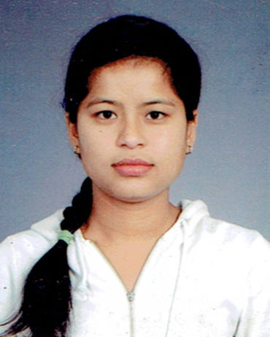DEBAKI
DEBAKI.371893@2freemail.com
POST APPLY FOR: Dental Hygienist/Dental Allied Healthcare (DHA)
PROFESSIONAL PROFILE:
Seeking a challenging position with a progressive organization that will effectively utilize my knowledge and expertise, where I can grow with the organization and prove to be an asset for its effective functioning, be a team player for the achievement of organizational goals and its success.
KEY SKILLS:
- Flexible and supportive team player with the ability to work to tight timescales
- Excellent verbal and written communications skills
- Capacity to work on own initiative as demonstrating a high level of team contribution
- Capable of managing stress as well as remaining calm under pressure
- Quick thinker and learner with the ability to multi-task
EDUCATIONAL ATTAINMENT:
- Dental Hygienist Dental Allied Healthcare Approved from Dubai Health Authority (DHA)
- Dental Hygienist from Council for Technical Education and the Vocational Training (CTEVT), Samaj School of Dentistry Kathmandu Nepal in 2011
WORKING EXPERIENCE
Work with ‘’Tamakoshi Co-operative Hospital’’ Ramechhap Nepal from Feb. 2013 to till date
- Prepare patient for dental treatment by welcome comforting seating and draping patient.
- Provides instrumentation by sterilizing and delivery instruments to treatments area positioning instruments for dentist access, suctioning passing instrument.
- Help dentist manage dental and medical emergencies by maintaining CPR certification emergency drug and oxygen supply.
- Educated patients by giving oral hygiene, plaque control and postoperative instruction.
- Maintain dental supplies inventory by checking stock.

