SAGAR SAGAR.371910@2freemail.com 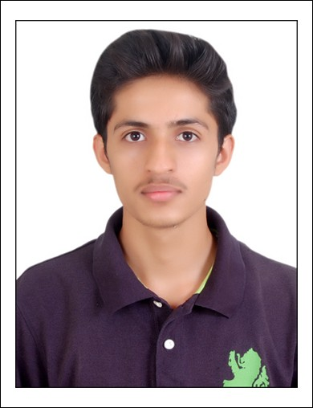
Sales Executive with experience in India

PROFILE
SAGAR GODSE is an accomplished Sales Executive with 2 years of experience in the profession. He has proven successful in organizing tasks, increasing sales and multiplying business from limited materials and resources. Is in search of a hospitable industry where his experience and skills would be of relevant use.

OBJECTIVE
To grow as an individual by gaining valuable experience from a well accomplished firm in an ever-growing industry.

EDUCATION
SHATABDI INSTITUE OF TECNOLOGY AND ENGINEERING, Nashik, Maharashtra, India.
Diploma in Electrical Engineering May 2015.

LANGUAGES

English – Excellent reading, writing and speaking
Hindi – Excellent reading, writing and speaking
Marathi – Excellent reading, writing and speaking

SPECIALIZED SKILLS
- Excellent interpersonal and communication skills
- Multi-tasking abilities with proficiency in organizing and managing different tasks
- Expert knowledge of handling administration and paperwork
- Skilled in book keeping and preparing statistical and financial records
- Thorough insights in overseeing stock levels and ordering supplies
- Proficient in assigning duties and scheduling shifts
- Ability of recruiting, training and supervising staff
- Expert marketing skills to promote business

PROFESSIONAL EXPERIENCE
Sales Manager (Part Time), Mahasagar Restaurant (2012-2017)
Mahasagar Restaurant is one of the popular restaurants located in Nashik with an annual turnover of 1.5 crore Indian Rupees.
Sales Executive (Full Time), Siva Nanda Electronics (2015-2017)
Siva Nanda Electronics is the leading manufacturer and Distributor of Electrical and Electronic appliances with an annual turnover of 50 crore Indian Rupees.

Responsibilities and Role details:

- Managing operations of a high-volume csompany to sell retail products, goods and services to consumers.
- Co-ordinate administration, budget, payroll, staff and vendors.
- Maintaining relationships with clients and demonstrating high standard quality products.
- Recruiting, training and motivating staff
- Generating detailed daily, monthly, quarterly and yearly reports on business, staff and profit.

OTHER INTERESTS
Bike Riding, watching YouTube videos, Gadgets freak

THANKS

SAGAR

