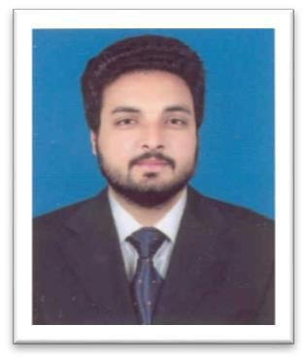

Umer
Umer.371933@2freemail.com

Objective

To pursue my career as an outstanding professional in a challenging and dynamic environment where I can nature and boost my skills to the utmost by complementing technical knowledge with practical experience.

Education

2012-2016 | B.Sc. Chemical Engineering | CGPA: 3.013/4
University Of Engineering & Technology Lahore.
2010-2012 | F.Sc. Pre-Engineering | 69.09%
Punjab College Sahiwal (Multan Board).
2008-2010 | S.S.C. Science Group | 83.43%
Govt. High School Sahiwal (Multan Board).
Final Year Project (2016-2017)

A Plant Design project on the production of 5000 Barrels per day of Shale Oil by the pyrolysis of Oil Shale.

Semester Project (2015)

Design and Fabrication of a Mixer Settler Extraction Unit.

Internee (2 June 2017-14 July 2017)

Engro Foods Limited, Sahiwal (Pakistan).

Computer Skills

•Aspen Plus (Process Design and Simulation of Chemical Plants)

•Aspen Hysys (Process Design and Simulation of Petroleum Refineries)

•ChemCAD (Process Design and Simulation)

•Microsoft Office Suite (Word, Excel, Power Point, Visio)

Interests

• Reading

•Movies

•Computer Applications •Traveling and exploration • Physical Training and fitness

References

Reference will be furnished on demand.

