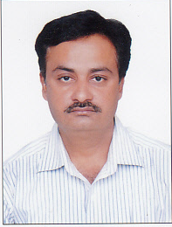
RESUME

SHAILESH
SHAILESH.371937@2freemail.com

OBJECTIVE:
Desire to hold a responsible and challenging position within a progressive organization, where I can develop my skills and prove my abilities for the growth of the organization and to grow with it.

STRENGTHS:
- Self-motivated, optimistic person, fast and eager to learn.
- Strong communication skills.
- Have a relevant work experience.
- Good in English.
- Flexible and responsible of all matters.
- Ability to handle multi-tasks and effective team player.
- Hard working.
- Computer literate in Microsoft Word and Excel and others.

EDUCATIONAL ATTAINMENT& TRAININGS:
B.COM

WORK EXPERIENCE:
Experience :- SAGAR JEWELLERS ( BHAVNAGAR)
( specility of all kind gold jewellry ornaments, pipe bali ,ring ,bengle,vertical mala) 25 years

Experience :- SAGAR GOLD AT (RAJKOT)3 YEARS
Experience :- LIFE INSURANCE ADVISER (since 2002)
Of india’s most reputed insurance company
(LIFE INSURANCE CORPORATION OF INDIA)
& Also working in mutual fund investment.

COMPUTER SKILLS:
Microsoft Office, Windows etc.

PERSONAL INFORMATION:
Date of Birth : 20th July 1970
Religion : Hindu
Nationality : Indian
Marital Status : Married
Languages Known : English, Hindi and Gujarati.
References : Will be furnished upon request.

I hereby declare that the above mentioned information is true and correct to the best of my knowledge.

