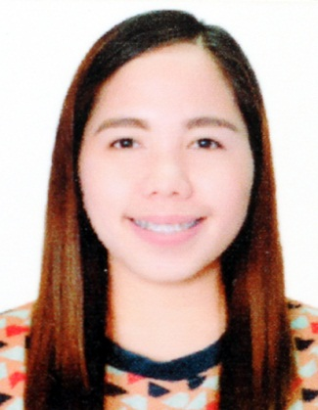
ROSE
ROSE.371943@2freemail.com

To obtain a job within my chosen field that will challenge me and allow me to use my education, skills and past experiences in a way that is mutually beneficial to both myself and my employer and allow for future growth and advancement.

SKILLS

- Above average English communication and people skills
- Knowledgeable in Microsoft software (MS Office Word, Excel, Outlook)
- Initiative and Enthusiasm
- The ability to work calmly under pressure
- Good planning, Analytical Skills and Organizational Skills
- Administrative work, Secretarial and Receptionist work

WORK EXPERIENCES

- MEDICAL TEAM ASSISTANT cum CUSTOMER SERVICE REPRESENTATIVE (Call Center)
May2015- March 2017
Convergys Philippines Inc.
Quezon City, Philippines

- Making inbound and outbound calls to each hospital and clinics for arranging admissions, laboratory services and follow up cares.
- Updating and filling patient medical records.
- Coding and filling out insurance forms.
- Handling correspondents and billing concerns.
- Researched and solved claim and billing issues
- Interfaced with insurance carriers and other healthcare providers
- Assisted patients with eligibility and benefit coverage questions
- Ensure documents met required standards.

- CLINIC NURSE cum FRONT DESK January 2014- March 2015
HOLY TRINITY PARISH CLINIC
Quezon City, Philippines

- Educates patients in the outpatient clinics, responds to consultations made by physician.
- Performs patient histories and physical examinations under physician supervision; evaluates results and monitors treatment plans, maintains record.
- Oversees patient schedules, appointments and procedures; attends and assists during surgical procedures.
- Answers phone inquiry
- Maintain health records, documenting each patient contact and updating patient profile.

- OCCUPATIONAL HEALTH NURSE cum FRONT DESK October 2012- July 2013
HEALTH FIRST
Mandaluyong, Philippines
- Nursing Assessment ( Vital signs, Medical history taking)
- Assists in consultation and medical procedures.
- Perform Front Desk tasks (Answering phone calls, set-up appointments etc.)
- Encoding/ recording of patient information
- Patient follow up
  - Health benefit ( in-patient, out-patient ) Referral system
  - Patient health record maintenance
  - Return to work clearance

- CUSTOMER REPRESENTATIVE (Call Center) January 2011- March 2012
TELETECH HOLDINGS CORPORATION
Quezon City, Philippines

- Handle 80+ calls daily, with duties including presenting relevant product information, customer care, billing, technical support and complaint resolution.
- Assists customers and arranges payment terms in accordance with established guidelines.
- Negotiate effectively and obtain best results for both the customer and the Business.
- Manage and answer first level customer inquiries and complaints.

SEMINARS ATTENDED

Updated Intravenous Therapy Training Capitol Medical Center, Philippines
March 9-11, 2016

Basic Life Support in Adults and Pediatrics International training Center, Dubai UAE
(AHA and DHA Accredited)
May 5, 2017

EDUCATION

BACHELOR OF SCIENCE IN NURSING
OUR LADY OF FATIMA UNIVERSITY – MANILA, PHILIPPINES
Graduated – MARCH 2009

