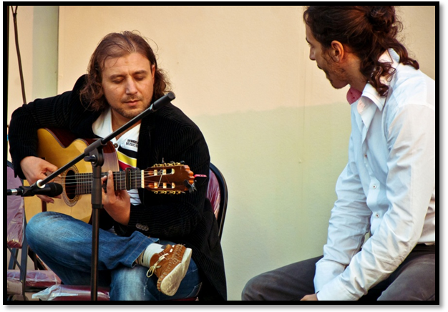
Mouhamed
(Flamenco Guitarist)
Personal information

Name: Mouhamed
Nationality: Syrian
Profession: Musician Guitar Teacher
Visa state: Resident visa (Partner)\
Email: mouhamed.371951@2freemail.com

Qualifications:
Diploma Guitar Certificate -Russia
Business studies institute -UK
Certificates from the hotels management
Work experience:

My Music
I have studied jazz flamenco guitar and composition to the highest level and have gained work experience in many
Schools and Five stars hotels including
- Shangri-La hotel
- Al khalidia palace 2003
- Madenat Jumeirah 2006
- Arabic culture center in Sharjah
- Planet Hollywood (Seville's) Wafi 2004
- Sheraton Jumeirah 2009
- Royal mirage…
- Bab Al Shams 2007 And many more….

Also gained work experience in very well known Schools in Dubai as a part time job teacher:

- Dubai British School
- Royal Dubai School
- Up Town School
- Horizon School
- GEMS School and many more ..

Repertoire:

Includes Classical & Modern Flamenco for the best guitar players in the world such as:

Paco De Lucia
Tomatito
Vicente Amigo And many more ..

Performing all the style in Flamenco Music
1. Buleria
2. Taranta
3. Solea
4. Fandango
5. Rumba

Thanks for your time and should be there any further information you require from us please do not hesitate to contact us at any time.
We also enclose our professional certificates for your perusal.

