NEETU
NEETU.371993@2freemail.com 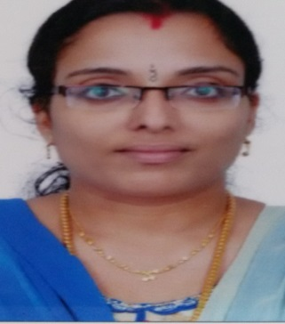

Career Objective:
To strive to the best of my ability, excelling in any field I work. Giving credence to attributes such as Integrity, Sincerity, Hard work and Team spirit. To be associated with a reputed organization, with career growth potential providing opportunities for advancement while allowing me to utilize my experience and specialized skills with the dedication and commitment to be successful in my duties.
Educational background:
1. MBA in Banking and Finance specialization.
2. M.com with (Marketing) from Calicut University.
3. B.com honor’s (Computer Application), Calicut University in year 2011 with 74%.
4. PLUS TWO (Commerce) with Computer Application in year 2009 with 85% from Higher Secondary Board, Kerala.
5. Passed High school from Bethany St. John’s English Higher Secondary School in year 2006 with 77%.
Working experience:
Post held: Lecturer
Institution: Mar Dionysius College, Pazhanji, Thrissur Kerala India
Duration: 2015 to March 2017.

Job summary:

1. Actively involved in teaching subjects related to Management like Basics of Business Management, Investment Management, and Financial Management etc.
2. Actively involved in taking regular classes as well as arranging industrial visits, Seminars and all other activities.
3. Actively involved in teaching subjects related to Commerce like Basic Numerical Skills, Business Regulatory Framework, Entrepreneurship Development, Principles of Management and Business Ethics, Marketing Management and E- Commerce, Quantitative Techniques etc...
College Name: Mar Dionysius College, Pazhanji
Designation: Lecturer

Achievements:

1. Certificate of presentation in the national seminar on Innovative Management Practices for Business Excellence in Sree Neelakanta Government Sanskrit College, Pattambi
2. Certificate of participation in the regional seminar on Innovative Horizons in Banking Sector, Sree Vivekananda College.
3. Actively participated in General Quiz, Story writing, Poem writing, Drawing, Essay competition etc..
4. Got First Prize for4*100M Relay race at Bethany St. John’s English Higher Secondary School annual sports.
5. Won competitions in: Western Music, General Quiz, Story Writing & Poem Writing
6. Conducted a well accomplished project on the topic of Service Quality in Elite Hotel, Guruvayur.

Computer Literacy:
1. Windows 2010
2. Windows XP
3. MS OFFICE 2010
4. Proficiency in Tally ERP9

Hobbies:
1. Reading books
2. Net surfing
3. Hearing Music

Personal Profile:
Date of Birth: 03/08/1990
Marital Status: Married
Languages known: English, Hindi and Malayalam.

