ISABEL
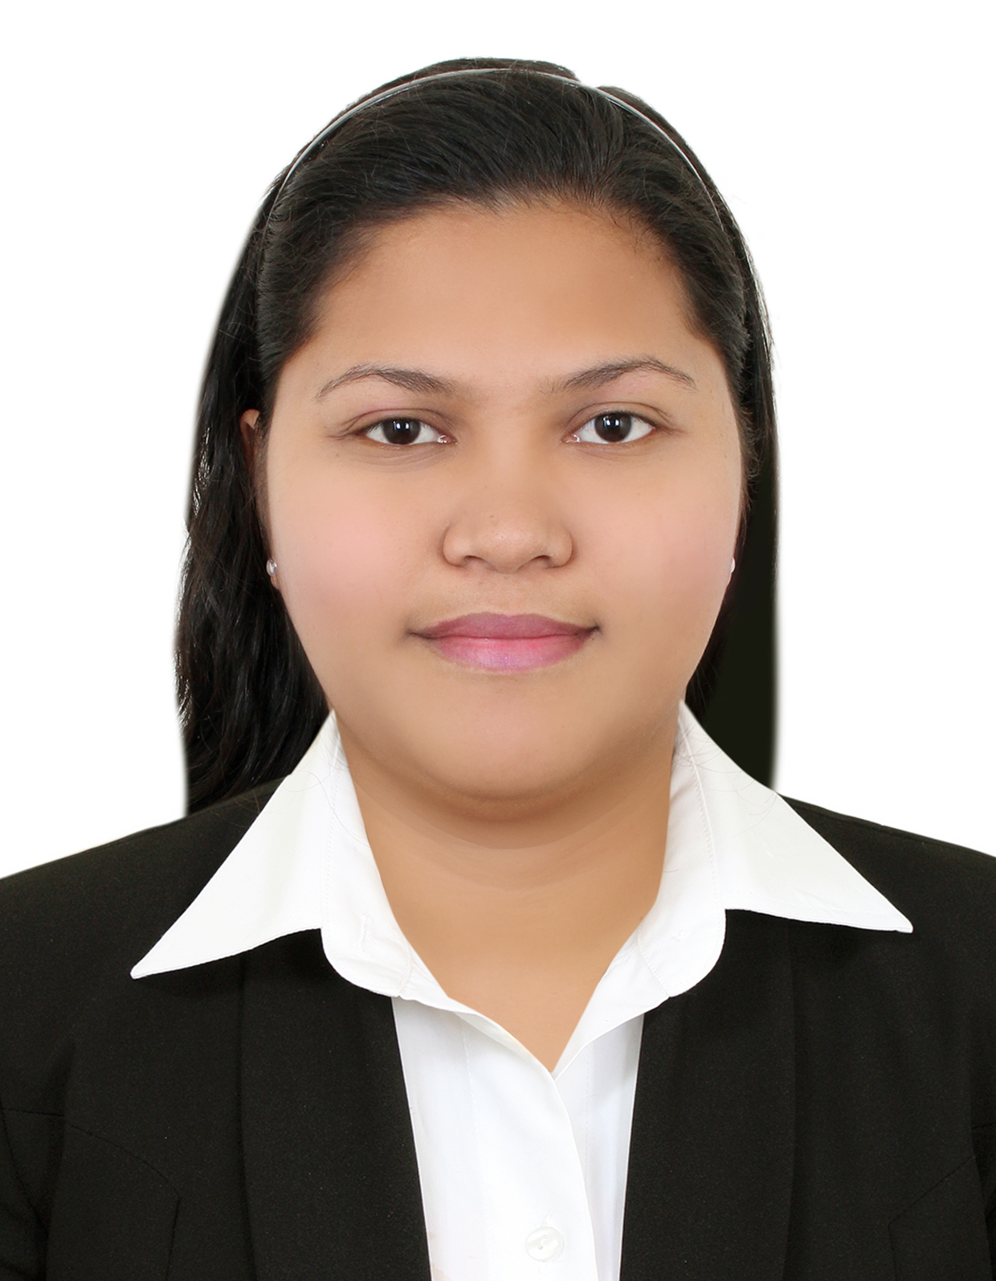

Colored Picture

ISABEL.372025@2freemail.com

Career Objective :

To impart the knowledge I gained and to pursue career development in line with the mission and vision of the company wherein the gained knowledge can be used for its good advantage and contribute to the success of your reputable company.

Performance Profile :
- Energetic and self – motivated Dental Assistant with 3+ year’s hands-on experience.
- 2+ year’s progressive experience as a waitress and server at restaurant.
- Highly skilled in greetings patients.
- Effectively set up tables, prepare and serve food and beverages according to set instructions.

Core Competencies and Skills :
- Cooking - Writing/Taking Orders
- F&B Service - Table Preparation/Cleaning
- Sanitation - Menu Recommendation
- Computer Literate (Microsoft Offices, Internet Browsing)
- Clerical work as per instructed.

Professional Experience :
JRD Dental Clinics – Dental Assistant/Secretary – September 2014 – April 2017
Duties and Responsibilities:
- Prepared patients daily to undergo dental procedures and assist dentist with sterilizing or disinfect instruments, setting up instruments trays and preparing materials.
- Scheduled appointments and send reminders and fill in insurance documents, prepare bills and receive payments for dental services.
- Take and record patient medical and dental histories and vital signs and record treatment information in patient records with 100% accuracy.
- Maintain a clean and joyful environment of the dental clinic.
- Monitor dental supplies and equipment inventory.
- Performed clerical duties related to dental program.

Charlie Wanton Restaurant – Restaurant Waitress – May 2012 – July 2014
Duties and Responsibilities:
- Welcome customers as they arrive and ask for seating preferences.
- Presents the menu to customers, answer queries about it and make suggestions if necessary.
- Takes orders from customers for food and beverages, writes down or memorize the orders and enters information into the computer for transmittal to the kitchen.
- Deliver orders to the table in a timely manner.
- Collects the customer’s payments and prepares bills.
- Prepares and tidies up the tables or counters; make sure there are enough salt, sugar, pepper and other condiments and napkins in every table or counter.
- Clean tables and ensure that they are bussed appropriately.
- Performs other tasks assigned by supervisor or manager from time to time.

Educational Attainment:

Primary Cupang Elementary School Cupang Antipolo City
1995 – 2001

Secondary Roosevelt Colleges
J.P.Rizal St. Lamuan Marikina City
2001 – 2005

Tertiary ICCT Colleges Foundation, Inc.
V. V. Soliven Ave. II, Cainta, Rizal, Philippines 1900
Associate in Hotel & Restaurant Management (Undergraduate)

Personal Information:

Date of Birth : June 09, 1989
Place of Birth : Antipolo City
Height / Weight : 5’8” / 70 kgs.
Civil Status : Single

