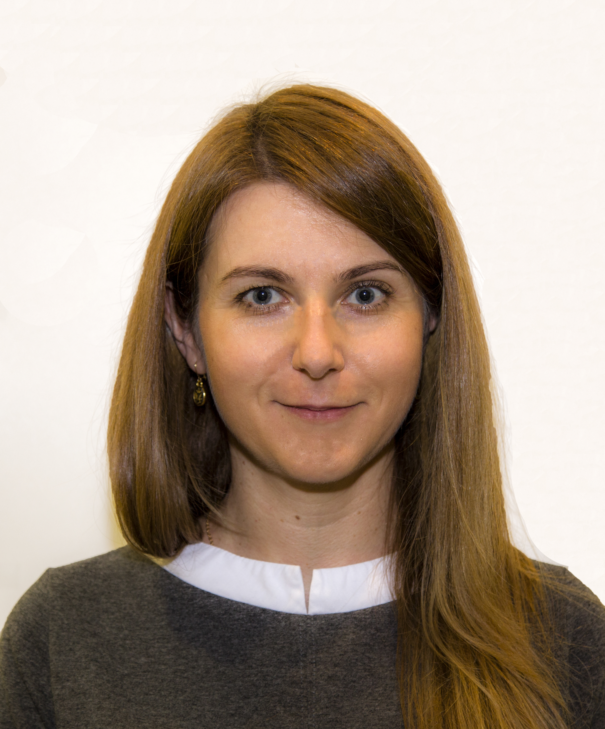
INNA
INNA.372043@2freemail.com
Administrative Assistant & Sales –Business Development Professional
A Senior Administrative Assistant to the Chairman with over 14 years of experience working in various multi-cultural organizations. Proactive and well-organized in rendering accurate and timely administrative assistance across various departments, covering various aspects such as corporate communications, travel management, event coordination and management of the Chairman’s activities.
Well-presented personality with strong professional etiquette and ability to build effective work relationships while coordinating complex operations. Skilled at generating intuitive solutions, sales operations, business development, project support and coordination, brand management and direct marketing.
Fluent in English, Russian & Ukrainian
Valid UAE driving license

Education
Bachelor of Arts in Foreign Languages (English, German & World Literature) 1997 – 2002
Kirovograd Vladimir Vinnichenko State Pedagogical University
[In partnership with Montclair State University, U.S.A. and Oxford University, UK]

Key Expertise
- Administrative Support | - Office Management | - Presentations
- Travel Management  - Event Administration | - Time Management  - Operations Coordination | - Data Management  - Staff Training
- Business Development  - Business Interpreter | - Filing/Archiving  - Business Consultant | - Office Procedures  - Sales Support

Work Experience
Assistant to the Chairman
Dubai, UAE
Al Aroud Group Jul 2012 – Present
Achievements:
- Successfully developed and coordinated ‘Russian Cultural Nights’ – two high profile events with exclusive Russian Pianist organized in Al Etihad Towers (Abu Dhabi) and Madinat Theatre (Dubai) for local and foreign diplomats. Undertook full accountability towards event administration, managing activities from invitation design, rentals, hotel accommodation management, catering to other ambience factors.
Key Responsibilities
- Reporting directly to the Chairman and managing multiple projects as assigned pertaining to vast lines of business, community and personal interests such as private and diplomatic events.
- Organizing calendar, travel (visas, tickets and hotel stays), meetings and schedule arrangements for the chairman and management team, including initiating contact, securing appointments and other facilities.
- Liaising with other teams to ensure the Chairman’s preparation for meetings, presentations and other engagements are done smoothly.
- Performing various functional activities such as taking phone calls, maintaining personal & official files, keeping corporate record for multiple entities, supporting marketing, assisting strategic planning, drafting minutes of meeting, creating documentation, filing, storing, retrieving business and personal activities.
- Handling financial and accounting matters for the Chairman with utmost confidentiality; drafting and sending business and private correspondence.

Business Development Executive
Dubai, UAE
Abstract Group Ltd Aug 2010 – Jun 2012
(HQ in BVI, UK)
Key Responsibilities
- Analyzed and identified new business relations, generated and negotiated new income sources for the company.
- Ensured adherence to company policies and protocols while gaining customer satisfaction; researched companies and decision makers’ online and social media to explore new leads and prospective markets.
- Communicated with potential clients via email or phone calls to build rapport and set up meetings; planned and oversaw new marketing initiatives.
- Represented the company at conferences, meetings, promotions, and industry events; prepared PowerPoint presentations and sales displays.
- Developed quotations and proposals for the clients; updated clients about new developments in the company’s products and services.

Sales Projects Coordinator
Odessa, Ukraine
TNT Express [Regional Office] May 2004 – Jun 2010
(HQ in Hoofddorp, Netherlands)
Achievements:
- Gained regional profit of 68% whereas the total number of customers rose by 44% during Jul 05 – Jul 07; performed ad hoc functions as head of the regional office.
Key Responsibilities
- Handled and managed prime accounts such as SGS Ukraine, Maersk, Economou and Odemara; acted as HR Manager, established and conducted training programs for sales team.
- Performed research and analyzed potential customers in the region; devised and developed Regional Office’s annual sales plan.
- Organized and established prospective sales territories, quotas, targets and goals; handled direct sales to existing and prospect clients.
- Planned, developed and maintained a computerized CRM for existing and prospective clients’ database; designed, devised and managed the strategy of customer support and retention.
- Developed innovative ideas and drafted offers for direct mail and marketing to major accounts; planned, organized and carried out direct marketing activities while adhering to the allocated budget.

Past Experience
Business Projects Coordinator & Interpreter
Odessa, Ukraine
Ukrainian – American Business Symposium “Global Leadership” Jun 2005
(Held by Global Leadership, INC with HQ in Atlanta, USA)
Responsibilities: Arranged & coordinated negotiations between American business team & representatives of local businesses; acted as an interpreter during business meetings between the American business team & representatives of local businesses.

Business Projects Consultant & Interpreter
Odessa, Ukraine
Ukrainian – American Business Symposium “Global Leadership” Aug 2003
(Held by Global Leadership, INC with HQ in Atlanta, USA)
Responsibilities: Analyzed, interpreted & determined business potential of the region; accompanied the American business team while visiting local businesses; acted as an interpreter during meetings while visiting local businesses; attended to visiting customers, communicated with them on their requirements and provided assistance.

IT Skills
MS Windows 7, MS Office (Word, Excel and PowerPoint), MS Outlook
Trainings & Certifications
- Certificate of Executive Secretary, Zabeel International Institute of Management & Technology, Dubai, UAE – March 2014
- Certificate of Practical Negotiations, Golden Staff, Alushta, Ukraine – Sept 2006
- Certificate of Effective Negotiations in Sales, Management Training International Ukraine, Ukraine – Sept 2005
- Certificate of Selling Excellence, Info Manager, Kiev, Ukraine – Jun 2004
References - Available on request

