Application for the post of Plant Operator

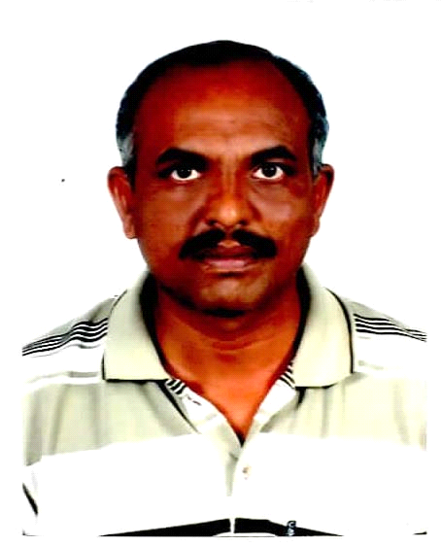

Personal Information

- Name : RAMALINGAM
- RAMALINGAM.372048@2freemail.com

OBJECTIVE AT A GLANCE

- A responsible and challenging position in oil & gas, production plant, Water &Waste Water Treatment plant field that will allow me to explore my abilities, skills and sense of dedication towards my duties with the sole aim of seeing the growth of the organization and its people and hence myself . Use PPE and follow HSE polices.
SUMMARY OF EXPERIENCE
- A result oriented professional with rich experience of 21 years in Process, Utility Plant Operation( 8 months in Oil plant)
- Educational Qualification:
- Higher Secondary School Passed in Mathematics group
- NCVT Attendant operator( Chemical Plant) Passed 3 years course.
.
CAREER PROFILE

 | Designation | Reporting Authority | Duration
GISCO, Gulf Industrial Services Company, Abudhabi | Swimming Pool Technician | Supervisor | From October 2016 to Still
ADNOC-Abudhabi National Oil Company | Terminal Operator | Plant Supervisor | From October 2015 to June 2016
ADSSC-MWWTW O&M by Kharafi National Co L.L.C (U.A.E) | Senior Plant Operator | Process Engineer | From March 2012-to 4th July 2015
Tamilnadu Water Investment Company  Ltd(TWICL), Chennai | Plant Operator | Plant Manager | From April2009 – Feb 2012
Sterlite Copper Industries India Ltd, O&M byIon Techniques (P) Ltd, Tuticorin. | Plant Operator | O&M Manager | From March 2007 – April 2009
VVD Coconut Oils(P) Ltd, Tuticorin | Process Operator | Production Incharge | From January 2006 to April 2007
ADSSC-MWTW O&M by Wesco(Weir Engineering Oil & Services Co.)Abudhabi-UAE | Plant Operator | Shift Supervisor | From August 2000 to November 2005
SKM Egg Products Export (I) Ltd, Erode. | Utility Operator | Plant Engineer | From June 1997 to August 2000
DSQ Bio Tech Ltd, Cuddalore. | Process Operator | Process  Engineer | From April 1994 to June 1997
Southern Petrochemical Industries Corporation Ltd, Tuticorin | NCVT Chemical Plant Operator (Govt.Act.Apperencticeship Trainee) Course Passed. | Manager (Training) | From 1991 to 1994
Job profile in ADNOC
ADNOC is one of the leading oil supply and distributor in the GCC Countries.
Oil receiving to Tank Farms from the Ship. Operation for Jetty, Receiving tank change over, Dyeing, Gauging, and Loading to Trucks, Calculate End of day Reading and Obey Shift Supervisor Comments and Instructions.
Mafraq Waste Water Treatment Works, Abu Dhabi, U.A.E
- Monitor and control the flow and processing of water, sludge and effluent.
- Working all area’s fields (Area Preliminary, Secondary Treatment Plants, TTPS, Sludge Digestion Plant and Odor Control Plants, Decanter )
- Operating SBR Plant.

Tamil Nadu Water Investment Company Ltd(TWICL)
- Operation of the plant
- Activated sludge process , Air Compressors and cooling towers.
- Filtration (Quartz, Resin and Softener Service Regeneration and waste management)
- RO Section (Chemical Cleaning of RO and Reject management)
- .
- Sterlite Copper Industries India Ltd, O&M by Ion Techniques (P) Ltd, Tuticorin.
- Operation of 300 cum/day Zero Discharge waste water treatment plant.
Continuous monitoring of Process and the Equipments for their efficient performance.
- Equipments handled:
Pressure sand filter, Activated carbon filter, Bag Filter,
Ultra Filter, Micron Filter, Ro Plant, Multistage Evaporator & SeparatorV.V.D ADSSC-MWWTW O&M by Wesco(Weir Engineering Oil & Services Co.) Abudhabi-UAE
- Monitoring of plant parameters like pH, MLSS, Conductivity, Turbidity, TDS, BOD, COD etc
- SKM Egg Products Export (I) Ltd, Erode
- Monitoring of plant parameters like pH, MLSS, Conductivity, Turbidity, TDS, TH, BOD, COD etc
- Operation of softener & DM Plant(Operation and Regeneration)
- Equipments handled:
Pressure sand filter, Screening, Aeration, primary, Secondary settlement, Drying beds.
Activated carbon filter, Pumps and Valves.

- DSQ Bio Tech Ltd, Cuddalore
- Operation of TAPIOCA starch Powder , Dextrose Mono Hydrate and Dextrose liquid Syrup
- Operation of Separator, Dryer and Centrifuge.
- Operation of various pumps and valves
- Southern Petrochemical Industries Corporation Ltd, Tuticorin
- Operation Training in Utility Plant (WTP & BOILER)
- Operation Training in Sulphuric Acid Plant
- Operation Training in DAP Plant
- Operation of Gypsum Pilot
- .

- Academic Qualifications
- HSC Passed(Physics, Maths, Chemistry) in State Board 1989-90

- Technical/Computer education
- Certificate course of ms excel, ms words
- Typewriting Lower- First Class with Distinction from Technical Board of Tamilnadu.
Knowledge about safety
- Safety policy, Environment policy.
- Use of Fire fighting/safety equipment.
- .
Personal Particulars

- Date of birth : 10-March-1972
- Nationality : Indian
- Sex : Male

- Marital status : Married

- Languages known : Tamil, English, Hindi, Malayalam.

Declaration:

I, the undersigned hereby certify that to the best of my knowledge and belief, the data correctly describes my curriculum vitae, my experience and me.

