NICHOLAS

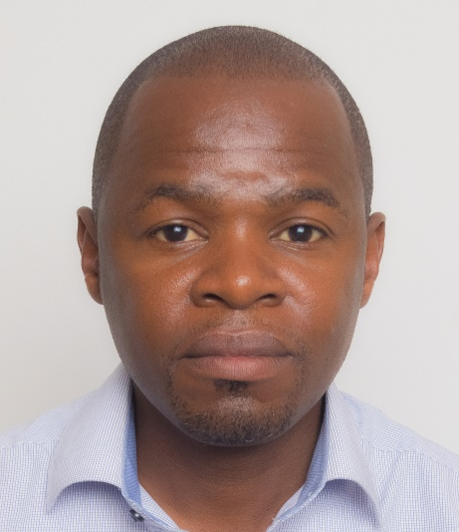
CAMERAMAN/VIDEOGRAPHER & EDITOR

NICHOLAS.372050@2freemail.com

PROFESSIONAL PROFILE
A versatile professional camera man with seven years working experience with a track record of working under pressure, and meeting deadlines.

CAREER OBJECTIVES
A creative, competent, productive Individual with experience Videography , public relation/customer service who is able to use available resources effectively and able to work independently to deliver according to the organizational goals and mission.
I seek a relevant and challenging position in an environment where my current qualifications and abilities will be of asset to the organization.

VISION
To work with people of diverse disciplines and cultures.

KEY COMPETENCIES
- Proficiency in using Adobe premiere pro cc, Adobe light room cc, Final cut x
- Vegas pro and Adobe audition

- Audio recording and audio mixing

- Studio camera operation

- Studio set maintenance

- Public relation

- Directing shoots

ACHIEVEMENTS
- Directed the Citam Buru Buru 10th anniversary Documentary
- Shot and edited a play on immorality trend
- Established social media interaction and profile videos for Citam Buru Buru
- Managed to train volunteers on basic camera operation, Sound and editing
- Managing Social Media Photos and Videos for AFC Leopards football club

- We recorded audio and filed for all Seminars for Independent Electoral and Boundaries Commission 2010

WORK EXPERIENCE

2017 – Present | CAMERA MAN AND VIDEO EDITOR – Hope TV  As video editor I was responsible for assembling recorded raw material into a finished product that's suitable for broadcasting. The material included camera footage, audio dialogue, sound effects and special effects and graphics. This is a key role in the post-production process and my skills determined the quality and delivery of the final product.  DUTIES AND RESPONSIBILITIES  - Acted as videographer as needed, shooting video for various types of projects.  - Managed video projects from conception to final edit  - Voice-Over for all Productions.
2010 – 2016 | CAMERA MAN AND VIDEO EDITOR – Various Projects  A camera man and a photographer. I was responsible for setup of cameras, lights and audio equipment’s, capture of raw material for postproduction purposes.  DUTIES AND RESPONSIBILITIES  - Videographer various types of projects. 2010 – 2016  - Assistant videographer and photographer 2015 -2016 at www.kingdavid.photography  - Managed video projects from Pre and post production 2010-2016 at www.hukzegraphics.com  - Live video streaming to Hope TV.  - Social Media content creation and management at Citam Buruburu  - Camera man in Next Big Thing project for Nation Media 2013  - Photographer for Mater Hospital 2012  - Audio Engineer for Independent Electoral and Boundaries Commission 2010
2003 - 2007 | SALES AND INDUSTRIAL ATTACHMENT  - Sales Representative – Lab and Allied Kenya 2003 – 2007  - Industrial Attachment – Pan Africa Paper Mills 2002 – 2003 April

SKILLS & QUALIFICATIONS
- Communication skills
- Leadership skills
- Teaching skills
- Script writing
- Digital Marketing
- Stage lighting & Camera set up
- Audio & Visual Cabling
- Live Sound Mixing Skills

HOBBIES
- Travelling
- Writing and Journaling
- Meeting new people
- Watching and Playing football
- Reading and Researching

AQUIRED TRAINING
- Online photography courses by Karl Taylor photography.
- Leadership and management by leadership training.

EDUCATION BACKGROUND
2001 – 2002 | THE KENYA POLYTECHNIC UNIVERSITY  Analytical Chemistry-Pass
1993 - 1998 | NYANG’ORI HIGH SCHOOL & MATURU SECONDARY SCHOOL  Kenya Certificate of Secondary Education (KCSE) C-
1985 - 1992 | AINSWORTH STREET & KOROMAITI PRIMARY SCHOOLS  Kenya Certificate of Primary

REFERENCE

Reference available upon request

