Position Applied:
AUTOCAD DRAUGHTSMAN
(ARCHITECTURAL / STRUCTURAL)
United Arab Emirates
Career Objective

To take up a challenging role with in a strategic management with focus to delighting the organization with my professional skills in the field of Planning and Drafting.

Working Experience
Having one and half years of experience in a construction company in State of Qatar.
Company Name: UrbaCon Trading & Contracting (UCC)
Position: AutoCAD Draftsman
Working Period: 20.01.2016 to 22.06.2017

Roles & responsibilities

- Proficient in creating drawings in AutoCAD.
- Prepare technical drawings and plans.
- Ability to draw and keep project drawings up to date.
- Preparing Shop drawings for Architectural
- Preparing As-Built Drawings, incorporating all Revisions Made during Construction Period.
- Familiar with XREF drawings.
- Assist in the review and recording of shop drawings.
- Making adjustment and changes to a variety of detailed drawings as necessary.
- Ability to generate applications drawing for new projects.
- A comprehensive knowledge of engineering design principals

Having one years of experience in a construction company in Sri Lanka.
Company Name: Central Engineering Consultancy Bureau (CECB)
Position: Structural Draftsman
Working Period: January 2015 to December 2016

Roles & responsibilities
- Reviewing information for completeness and accuracy.
- Checks plans.
- Transform AUTOCAD drawings into 3D drawings (If required).
- Prepare assembly and detail drawings on the basis of the information and instruction provided.
- Makes necessary calculations for drawing development.
- Prepares and assists in drawing revisions are required.
- Prepares As-built drawings in the prescribed computer sheet given by the Client/Consultant and assist in Project Close-Outs.
- Maintains knowledge of Company standards and incorporate these into engineering design.
- Performs other duties and responsibilities as may be assigned from time to time.

MILHAN

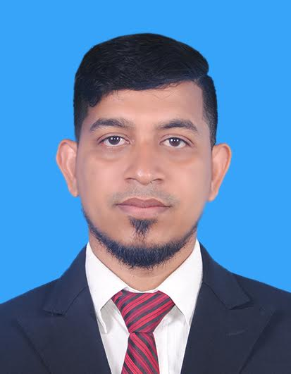

Email:
Milhan.372091@2freemail.com

PERSONAL PROFILE

Date of : 01st August 1987
Birth

Civil status: Single

Visa status: Visit Visa

Gender : Male

Nationality: Sri Lankan Muslim

Professional qualifications:

Successfully completed, CAD&BS (Computer Aided Designing & Building Studies) at the BCAS – British College of Applied Studies, Sri Lanka. 2014-2015.
The program CAD&BS is equaled to NATIONAL DIPLOMA IN CONSTRUCTION STUDIES. It is discovering overall view of Structural, dynamic construction and architectural fundamental in an industrial construction field. This programmed covered three qualifications.
- Diploma in CAD & BS (Pearson Qualification)
- Diploma in Construction Technology
- Diploma in MEP Drafting
- Certificate in Primavera P6

Tertiary Qualification

- Certificate in English
- National Dip. In ICT (NVQ Level 5)
- Certificate in Computer Application Assistant (NVQ Level 3)

Computer Skills:

- Strongest hands with using shortcut keys in all versions of AutoCAD
- Excellent knowledge in Primavera P6
- Sound knowledge in Photoshop
- Excellent knowledge in Microsoft office packages.
- Basic knowledge in 3D Max

Key Skills and Competencies:

- Able to quick learn
- Capable of working under pressure.
- Capable of working as a member with minimum supervision.
- Able to handle software easily

Communication Skills:

Mother tongue Tamil
Other Languages Good at English

I do hereby certify that the above particulars are true and correct to the best of my knowledge.

