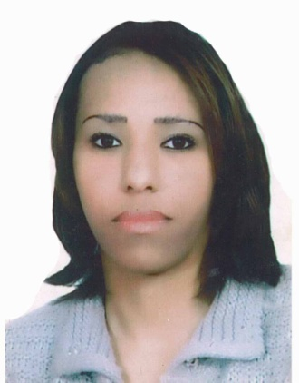
CURRICULUM VITAE
AMINA
AMINA.372102@2freemail.com
Presentation
An having a good presentation hotelier experience, been to continue this professional experience within your establishment.
DIPLOMA AND FORMATION
- 2001/2003:Degree in traditional restaurants in Center Hotel and Tourism Professional Qualification (CQPHT)
- 1999:Certificate in Fashion and Styling in The Institute Of Applied and Preparation Technology (Clothing Business)- ITA-
- 2006/2007:Certificate in Microsoft Office Word and Microsoft Office Excel from Center Abu Fares Al Marinie
- Has successfully completed training program and assessment in ”Basic Food Hygiene Training” in 22nd October 2012
TRAINING COURS AND EXPERIENCE PROFESSIONAL
- 21/07/2001 to 06/09/2001: Training course at* HYATT REGENCY HOTEL* as a commis polyvalent in the kitchen and the restaurant.
- 02/05/2002-30/07/2002: Training Course at *RIYAD DAR MOHA EL MADINA*as a commis polyvalent in the kitchen,reception and the restaurant.
- 01/05/2003-10/09/2003: Training Course at Bakery and Pastry *SOUSANA* as a commis in the pastry
- 21/11/2003-07/03/2004: in italiano restaurant *CASANOVA* as a assistant chef
- 18/04/2004 to 30/09/2004:as commis chef in piano bar *MAREMSTRUNG*
- 07/03/2005-13/06/2005:Cartering “MAYMANA” as much as cooking helpers.
- 01/01/2007-30/04/2007:in the Coffee-Shop, Pasty and Chocolates *LE MARRONNIE* as productive pastry.
- 01/12/2008 to 09/03/2010(+1month15 days a probation period) in oriental restaurant*SHORRAH* as assistant cook.
- For more than 1 year I worked under sub-contracting with different catering, coffee-shops,…
- 22/08/2012 to :07/08/2013:in *ROYAL MIRAGE HOTEL* as a demi-chef de partie.
- 07/04/2014 to :21/07/2014 :in *ROYAL CATERING * as chef de partie.
- 14/09/2014 to:22/02/2015 :in *AG HOTEL* as executive-chef-cook.
- 10/05/2015 at 08/01/2016:in *CITY SEASONS HOTELS*as a chef de parti
Responsability
- Resolved customer complaints regarding food service
- Train workers in food preparation in service, sanitation, and safety
- Provides customer service at all times, and ensuring the satisfaction of the guest within their stay
KNOWLEDGE LANGUAGES:
- Arabic: Read, speak& write.
- French : Read, speak & write.
- English: Average knowledge

