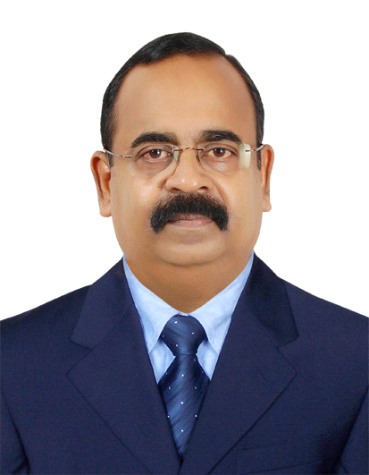Ahammed.
Ahammed.372103@2freemail.com

OBJECTIVE
Looking for a position of responsibility in the retail business, where my years of experience in showroom setup, purchase and marketing/promotional activities in the Supermarket and Department stores areas can be put to the benefit of the organization and my own career growth.
BRIEF PROFILE
- 20 years of experience in Gulf Region - Supermarket & Department Store, Food and Non-Food
- 10 years of Experience in India –various roles in the Garments &Textile field.
- Wide experience in retail business that include setting up of new Supermarket & Department stores, bulk purchasing, inventory control, staff deployment, staff training and promotional activities.
- Extensive knowledge of FMCG & Garments, Textiles and White Goods. Highly familiar with major brands from Europe and Asia.
- Very good knowledge of Indian pure silk sarees.
- Wide range of contacts in the wholesale and retail markets in Gulf region and India.
- Proven capability in handling more than 100 staff.
- Food and Non food (Hyper market level ) purchase experience .

KEY SKILLS
- Operations management of Group outlets
- Group purchase-Inventory control and optimisation
- Back store and GRV management
- Networking with partners in wholesale and retail markets
- Staff optimisationand deployment
- Training Delivery – Areas covered include LPO Management, PO creation, GP maximisation techniques, Waste reduction, Staff motivation, etc.
- Organizing new outlets .

EMPLOYMENT HISTORY (Gulf Region)
2017 March to Present: Purchase officer FMCG, M/s Ramez Group, Sharjha
2012 Oct: 2016:ManagerRetail Division (FMCG : Dept. Store ) Al Manama Group, Ajman.
2009- 2012 July:Purchaser in Retail Division M/s Al Dhafra Co-Operative Society, W/R, MadinathZayed, Abu Dhabi.
2006-2009: Manager (Retail Operations), M/s. Baniyas Spike Group of Companies,W/R,MadinathZayed, Abu Dhabi
2003-2006: Purchasing/Marketing Manager (wholesale),Shilpa Fashions, Bahrain &Shilpakala Fashions, Dubai.
1996-2003: Sales Supervisor, Flair (KM Trading Group), Abu Dhabi

MAJOR ACHIEVEMENTS
- Successfully set up a Supermarket and Departmental store for M/s Baniyas Spike Group of Companies in BidaZayed with overall responsibility for show room design, purchasing, proper place allocation, bar coding, and staffing.
- Identified new products and independently handled sourcing and local sales promotion while working for Shilpa fashions, Beharin. Increase in sales revenue by 20%
- Expanded sales to include mass market accounts in Flair, Abu Dhabi
- Increased sales by 30% in the Textile and Sarees Division of Flair, Abu Dhabi, while working as Sales Supervisor
- Played a key role in increasing division revenues by three times, while working for Flair Abu Dhabi
DETAILS OF EXPERIENCE

From March 2017: Purchase officer M/s RamezGroup .Sharjha
Currently working on introducing new process for creating and executing Local Purchase Orders.
2012 Oct: 2016: Manager Retail Division (FMCG: Dept. Store) Al Manama Group, Ajman.
Responsibilities:
- Overall responsibility of the Outlet
- Purchasing and Inventory control
- Planning and implementing Sales Promotional activities
- Staff control
2009-2012 July:Purchase Officer, Retail Division (Food & Non Food) M/s Al Dhafra Co-Operative Society, W/R, MadinathZayed, Abu Dhabi .
Responsibilities:
- Wholesale procurement
- Pricing
- Proper place allocation and Listing.
- Planning and implementing Sales Promotional activities
2006-2009: Manager Retail Operations, M/s. Baniyas Spike Group of Companies (Food stuff whole sale & retail), BidaZayed, Abu Dhabi
Responsibilities:
- Planning of new show rooms
- Staff recruitment and deployment
- Wholesale procurement
- Proper place allocation and Inventory Control
- Sales promotion
2003-2006: Purchasing/ Marketing Manager, Shilpa Fashions, Bahrain &Shilpakala Fashions, Dubai.
Responsibilities:
- Manage whole sale Purchase from Gulf regions and India
- Identify and locally promote new products from India & Far East
- Manage Sales/Marketing Team
1996 – 2003: Sales Supervisor, Flair, Abu Dhabi (KM Trading Group), (Textiles, Sarees, Garments & Footwear)
Responsibilities
- Managing Sales Staff
- Expand sales to include mass-market accounts.
- Person In-charge of Textile &Sarees, Garments and Footwear division.

EDUCATION AND OTHER PERSONAL DETAILS
Qualification:Bachelor Degree in Commerce (course completed), University of Kerala, India
Marital Status/ Children:Married, one son and one daughter
Languages:Malayalam Fluent), English (fluent), Hindi (fluent), Arabic (working knowledge)

