RESUME

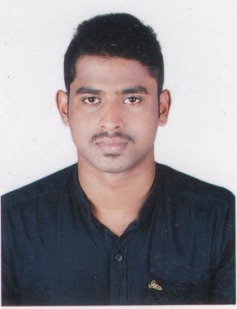

ABINRAJ

ABINRAJ.372109@2freemail.com

OBJECTIVE
Intend to build a career with leading corporate of hi-tech environment with committed & dedicated professionals, which will help me to explore myself fully and realize my potential. Willing to work as a key player in challenging & creative environment.

ACADEMIC PROFILE
- DIPLAMO IN PETRO CHEMICAL ENGINEERING(DOTE) 2014
Kongu vellalar polytechnic college.
PERCENTAGE: 71.54%

- S.S.L.C (State Board) 2011
St.Francis Xavier higher secondary school, Kaniyakumari.
PERCENTAGE: 70%

SAFETY COURSES

- 6 Month FIRE AND SAFETY COURSE completed in konghu vealalar Polytechnic college, Erode.

PROJECT EXPERIENCE

- Manufacture of gelatin for pharmaceutical needs at sterling biotech ooty.

WORKING EXPERIENCE

- At present working as a production operator trainee PIONEER JELLICE INDIA P.LIMITED.(From may 03 ̵ 05 ̵ 2014 to 04 ̵ 01 ̵ 2015).
- At present working as a production operator ARJUNA NATURAL EXTRACT. LTD Coimbatore. (From march 2015 to November 2016 ).
RESPONSIBILITY
- Controlling of all valves and pumps.
- Maintain the quality output products.
- Responsibility for the distillation process .
- Maintaining quality report Batch wise.
.

DECLARATION

I am also confident of my ability to work in a team. I hereby declared that the information furnished above is true to the best of my knowledge.

