CURRICULUM VITAE

ARSALAN  ARSALAN.372113@2freemail.com | 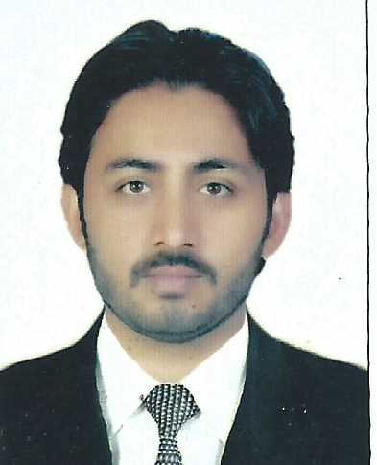

Position Applied for : SALES MARKETING

OBJECTIVE

To seek a challenging position in a reputed firm to invest all my professional expertise to contribute to the success and growth of the organization I work for and to develop my career to an optimum level.

EDUCATIONAL QUALIFICATION

F.A.
- Diploma in Embroidery & Fashion Designing

M/S ZONG TELECOM LTD PAKISTAN.

FROM JAN, 2015 TO JULY 2017

WORK EXPERIENCE

- Established quarterly sales goals and evaluated new products
- Developed strategies to increase sales of tech products
- Implemented customer service procedures to increase customer satisfaction
- Prepared quarterly marketing reports and forecasts
- Gathered stats on product updates and presented results at staff meetings.
- Work as an Microsoft Work. Microsoft Excel.
- Work an Computer Related.

SPECIALIZED SKILLS

- Marketing Strategies & Campaigns
- Corporate Communications
- Creative Team Leadership
- New Product Launch
- Public & Media Relationship.
- Focus Group & Market Research

STRENGHTS

- Flexible With Any Shift.
- Ability To Work Under Pressure
- Ability To Work With Different Nationality People

LANGUAGE KNOWN

- English & Urdu

PERSONAL DETAILS

Nationality : Pakistani
Sex : Male
Place of Birth : Faisalabad, Pak.
Date of Birth : 17-04-1987
Religion : Muslim
Civil Status : Single

DECLARATION

- I hereby certify that the above mentioned details are true to the best of my knowledge and belief.

