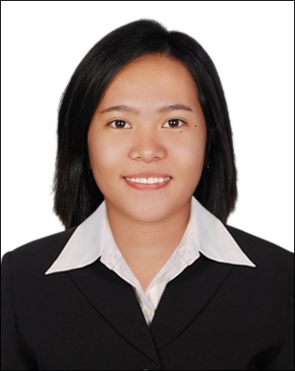
CURRICULUM VITAE

MARIE
MARIE.372116@2freemail.com

CAREER OBJECTIVE:

- to efficiently utilize my knowledge and skills in the business force arena as a tool for the betterment and attainment of company’s missions, visions, goals, and standards

PERSONAL ATTRIBUTES:

- Hard working and honest
- Excellent telephone manner
- Dedicated and success oriented
- Articulate and good communicator
- Able to work effectively in a fast busy office
- Ready to apply knowledge and willing to learn more
- Self-confident with professional and interpersonal attitude

WORK EXPERIENCE:

- STAR CYCLE MOTORS
District of Toril, Davao City, Philippines

- Marketing Officer
June 27, 2016 –June 21,2017

DUTIES AND RESPONSIBILITIES:

- Interface with customers and prospects in order to support a systematic identification of their needs.
- Develop a proactive and advisory-driven distribution of the full range products which the company offers.
- Take promotion activities by organizing road shows for new product launch or reactivating the marketing of existing products.
- Arrange, support, and participate in client calls and help them in identifying the product of their needs.
- Do sales analysis, arranging meetings with customers and do necessary survey as and when the company demands

- MAGSIGE MULTI-PURPOSE COOPERATIVE
District of Calinan, Davao City, Philippines

- Teller Officer
November 2015 – April 2016

DUTIES AND RESPONSIBILITIES:
.
- Receive and pay out money.
- Keep records of money and negotiable instruments involved in a financial institution's various transactions.
- Receive checks and cash for deposit, verify amounts, and check accuracy of deposit slips.
- Examine checks for endorsements and to verify other information such as dates, bank names, identification of the persons receiving payments and the legality of the documents.
- Enter customers' transactions into computers in order to record transactions and issue computer-generated receipts.

SEMINARS AND TRAININGS:

Computer Software Enhancement Training, Raissa Computer Center, Calinan, Davao City, May 2016

On-the-job Training, MAGSIGE-MPC, Bukidnon Road, Calinan, Davao City, November 2015 – April 2016.

Entrepreneurial Seminar, Holy Cross College of Calinan, DatuAbing Street, Calinan, Davao City, July 22, 2015.

Seminar Workshop on Statistical Tools, Holy Cross College of Calinan,
Calinan, Davao City, September 4, 2015.

Leadership Seminar, Holy Cross College of Calinan, Calinan, Davao City July 27-28, 2013.

Team-Building Workshop, Holy Cross College of Calinan, Calinan, Davao City, September 12, 2012.
SPECIAL SKILLS:

- COMPUTER SOFTWARE
- CUSTOMER SERVICE
- SINGING

PROFESSIONAL QUALIFICATION:

- BACHELOR OF SCIENCE IN BUSINESS ADMINISTRATION
MARKETING MANAGEMENT – APRIL 2016
Holy Cross College ofCalinan, Calinan, Davao City

PERSONAL INFORMATION:

Date of Birth: MARCH 28, 1995
Age: 22
Place of Birth: DAVAO CITY, PHILIPPINES
Citizenship: FILIPINO
Gender: FEMALE
Marital Status: SINGLE

AVAILABILITY TO JOIN: ANYTIME

