Julie
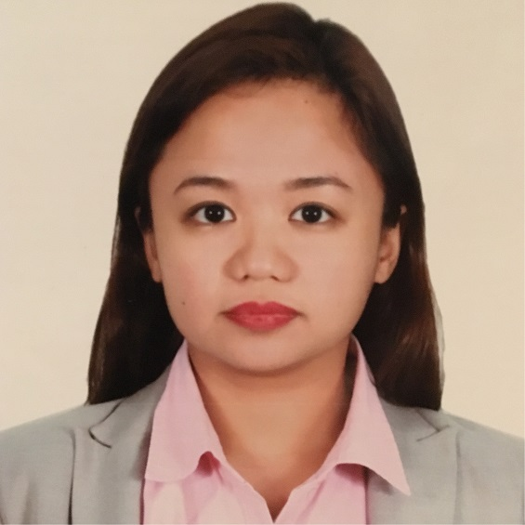
Julie.372120@2freemail.com
Instrumentation Engineer

WORK EXPERIENCES

Engineer, WorleyParsons, Qatar
Controls & Instrumentation
Project: Maersk Oil Qatar – CSCC Project
October 2015 to June 2017
Key Responsibilities:
* Engineering and selection of instrumentation complying with client standards and international regulations
* Coordination with vendors to clarify technical issues and specifications
* Preparation of workpacks for site execution
* Preparation of instrumentation deliverables, ie. Data sheets, technical bid evaluations, loop drawings, P&ID mark-ups, etc.
* MTO and instrument indexes for cable trays, junction box, MCT, Cables, glands, hook-ups and installation materials
* Ensures complete and correct execution of project at site through thorough closeout procedures and checks.
* Making as-built mark-ups & updating of all drawings to As-built status after checking at site

Engineer, Engineering Department, Transfield Services - WorleyParsons JV
Project: Malampaya - Shell Philippines Exploration (various projects)
2012 to 2015
Ensures as-built completion of all brown field projects executed for Malampaya CNG Platform operated by Shell Philippines Exploration. Completion activities include:
* Updating of all drawings to As-built condition after checking at site
* Compilation of closeout requirements of projects in various disciplines: Instrumentation, Controls and Automation, Piping, Mechanical, Structural, Electrical
* SPI updates for as-builts of instrumentation scope
* Coordination with Project Control Team to ensure validity of commercial closeout
* Initiating documentation updates such as data sheets, operating procedures, etc.
* Initiating SAP changes for completion of project – identification of functional locations, BOM’s, creation of Preventive Maintenance Routine procedures
* Initiation of onshore/offshore site survey activities for verification, corrections and as-building of documents under all disciplines: P&ID’s, Cause and Effects, Loop drawings, Layout Plans, Wiring Diagrams, Isometrics, Structural Details, Procedures, Manuals, Data Sheets, Cable Schedules, etc.
* Coordination and verification with vendor to provide as-built drawings
* Weekly closeout progress reports and tracking of all drawing activities done by CAD personnel
* Raising technical queries to offshore for verification to incorporate in As-built documentation
* Coaching of members of team on close-out procedures and CAD activities

CAD Engineer, Engineering Department, Transfield Services - WorleyParsons JV
Project: Malampaya - Shell Philippines Exploration (various projects)
2012
Closeout and construction drawings for various disciplines (using Autocad, SPI and 3D softwares):
* P&ID, PFD
* Wiring Diagrams
* Cause and Effects
* Piping Isometrics
* Layout Plans
* Interconnection diagrams for Junction boxes and Marshalling cabinets
* Loop Drawings
* Structural Layout and Details, etc

R&D Engineer, Orthopaedic International Inc.
2011
Development of implants and instruments used by surgeons in orthopaedic operations from design to design transfer to manufacturing using Solidworks. Development process of products includes:
* Risk management documents (product and process)
* Engineering drawings
* Rapid prototyping jigs and fixture designing
* Project monitoring reports
* Metal fabrication techniques (bending, drilling, cutting)
* 3D modelling & 3D printing
* Process specification documents
* Quality control specification documents

CAD Engineer (CATIA), Toyota Tsusho Corporation
2008-2010
Method standardization training with client. Assisted and was trained in Guangzhou Toyota Motor Corp Project - CATIA (similar to Solidworks) Assembly in Nagoya, Japan. Made 3D models of an assembly automation facility.

TRAININGS

Accelerated Course in Instrumentation and Control, Philasia School of Instrumentation and
Automation, 2014 to 2015
BOSIET - Basic Offshore Safety Induction and Emergency Training, 2014

ON-THE-JOB TRAINING

Safety, Health and Environment Trainee, Engineering Department, Nestle Philippines Corporation, 2007
Attended seminars, assistant to SHE Manager, assisted in preparations for ISO 9001 and ISO 14001 audits of Nestle plants all over Luzon.

Sales and Marketing Trainee, Retail Department, Pilipinas Shell Petroleum Corp., 2007
Assistant to Shell Select Retail Manager

EDUCATION

Master of Science in Mechanical Engineering, Major in Mechatronics
De La Salle University (18 out of 36 units completed)

Bachelor of Science in Manufacturing Engineering and Management, Major in Mechatronics and
Robotics, De La Salle University
2003 to 2008
Thesis: Compression Molding of Recycled Polypropylene Wastes into Plastic Floor Tiles
A machine prototype capable of utilizing rejected polypropylene plastic products as plastic floor tiles.

SOFTWARE SKILLS

* Autocad
* CATIA V5 (3D modeling software)
* PDMS
* EDS (Engineering Data System)
* Intools (SPI)
* Labview
* MATLAB
* Visual Basic
* SAP
* MS Office (Advanced level in MS Excel)
* C++
* Solidworks (3D modeling software)

PERSONAL BACKGROUND

Born on October 31, 1986 in Abu Dhabi, UAE. Filipino citizen. Fluent in English and Filipino. Results oriented. Advanced level in 3D and 2D modeling softwares.

I can work with minimal supervision, deliver to objectives even under pressure. Able to work in a fast-paced environment. Attentive to details. Team player.

Currently residing in Dubai under visit visa. Immediately available.

