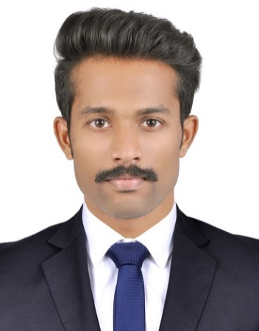
Emil emil.372137@2freemail.com
Career Objective
To be a part of an organization which would make me more resourceful and innovative by providing a platform for the growth of my skills gained during my engineering program and to contribute to the development of the organization

Education Timeline
10th CBSE
The Indian High School,Dubai

B.tech CBCS
Karunya University
Coimbatore

12th CBSE
The Indian High School,Dubai

2011 2013 2017
8.6 80% 8.39

Skill Set
Software Programming language
Pro E C
ANSYS C++
Inventor
Industrial Training
Bus body acceptance standard – Ashok Leyland (01.06.2016 – 14.06.2016)

Certification Courses
- Completed Course on DIGITAL PROTOTYPING using Autodesk Inventor From KKM SOFT (P)LTD
- Cambridge English Entry Level Certificate in ESOL International (Business English)-Level B1
- Completed a course on C++ Language from G-Tec

Workshop Attended
- Wireless All Terrain Robot Workshop on 04.09.2016
- Value Education Workshop on Leadership in association with Global Leadership Summit

Extracurricular Activities
Audio & photo editing, Photography, Dance, Guitar,Beatbox.

