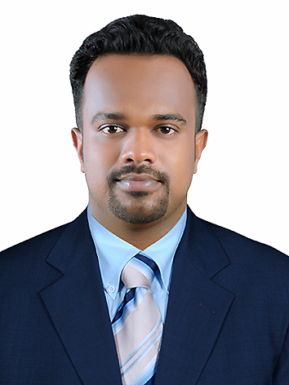

SABARI
SABARI.372144@2freemail.com
Email ID: sabarisukumaran7@gmail.com
VISA DETAILS: UAE Visit Visa Upto 30th Sep 2017
A vibrant and passionate professional having worked in different diversified sectors like shipping, telecom and event management. During the tenure I have garnered immense experience in facilitating customer interactions,business promotions, target meeting, sales management and service provisions to clients. I can manage people, communicate effectively and have great convincing and negotiation skills.

OBJECTIVE
I am in quest of challenging avenues that can excite and motivate me to contribute immensely towards the organization’s growth and expansion of my professional career. My immediate objective is to wear the hat of a responsibility driven professional in an organization that avails a motivating work atmosphere.
Opportunities that would excite me include but are not restricted to:
Admin assistant– Customer Care – Event Management – Office documentation – Sales management

professional synopsis

Hadi Hammam Saudi Arabia
Seaman in an off shore Supply vessel 22/04/2015 to 20/02/2017

C4 Events India
Event Coordinator 02/03/2014 - 31/03/2015

Idea Cellular LTD India
Customer Services and sales executive 15/01/2012 - 20/02/2014

Education
Diploma in Nautical Science - 67% aggregate. IMU Chennai
Indian Maritime University
Higher Secondary Examination (12th) - 68% aggregate HSE
MSM SCHOOL
A.I.S.S.E (10th)–75.2% aggregate. CBSE
SNCS
Technical Proficiency
- Advanced browsing skills and MS Office

MY PRO FORMA:
Name: Sabari
Date of Birth: 15th August 1991
Gender: Male
Nationality: Indian

I wish to represent myself in obvious terms by means of my Curriculum Vitae, which are above for your kind surveillance. I assure you that it would always be my endeavour by diligence and attention to deserve your confidence.

