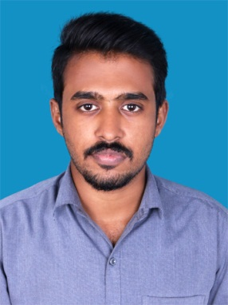

SHAMEEM

Shameem.372248@2freemail.com

OBJECTIVE

To be an expert in my area of work, with a passion for challenges, innovation and working with people and communities. Seeking a role, where I will be able to apply my skills, work experience in development of advanced technology by making a difference through quality, with strict adherence in achieving the organizational goals.

PROFILE

Graduation in Bachelor of Technology in Mechanical engineering with Academic experience of around one year . I am organized, efficient and accurate in my work efforts. I work actively, confidently, self-driven with a positive working personality by maintaining a good bonding within the organization.

ACADEMIC QUALIFICATION

Degree / Certificate | College/School | University/Board | Year | Marks  Obtained
B.TECH  (Mechanical engineering) | Vedavyasa institute of technology | Calicut University | 2015 | 63%  (First class)
Higher Secondary (12th) | NSS HSS ,Calicut | Kerala State board | 2011 | 75%
SSLC (10th) | Malabar Christian college HSS,  Calicut | Kerala State board | 2009 | 78%

PROFESSIONAL EXPERIENCE

Organization: SUZUKI APCO MOTORS, Calicut
Designation: Service Supervisor

Duration: From 10thJune 2016 To31july 2017
Key Responsibilities & Duties:

- Helping the team understand performance targets and goals.
- Scheduling work hours and shifts.
- Assisting in resolving emergencies. For example, a quality or a customer problem may be escalated to the team supervisor for handling.
- Identifying and resolving workplace problems, including tardiness or absenteeism.
- Providing reports and activity updates to management.

internship, project and training
- Successfully completed ‘Inplant Training’ at Cochin Shipyard Limited (A Govt. Of India
Enterprise), Kochi in the Ship Building/Ship Repair &Utilities and Maintenance Department - 2014
- Major project – ‘aqua silencer’ -2015
- Minor project – ‘york arm’-2014

ORGANISATIONAL/MANGARIAL SKILLS

• Served as Head of VVIT Mechanical Association Committee, 2014-15.
• Actively participated in the event organizing of Intra Cultural College Fest, Naadam, 2015.
• Conducted Seminar on 3D Printing at Vedavyasa Institute of Technology, 2015

All the information provided above are true to the best of my knowledge and experience.

