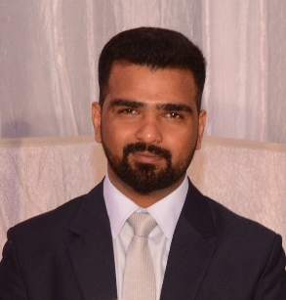
FALAK

FALAK.372252@2freemail.com

CAREER OBJECT:

To signify and contribute my knowledge and expertise in successfully fulfilling assigned tasks and responsibilities through high regard for work advancement and growth of the company. Also willingness to gain new Idea to your respective company.

WORK EXPERIENCE:

- PROJECT COORDINATOR Dec. 15, 2015 – Feb 28, 2017

BADER HASSAN AL-HUSSAINI SONS & CO.
Saudi Aramco Project
Dhahran, Kingdom of Saudi Arabia

- SOFTWARE ENGINEER Nov 10, 2014 – Oct 30, 2015

TECHNOLSYS SOFTWARE PVT. LTD.
CC2 Level 5, Arfa Software Technology Park
Lahore, Pakistan

- IT MANAGER & SOFT. ANALYST Oct 1, 2013 – Nov 5, 2014

NOOR PVT. LIMITED
2nd Floor, Naqi Market, 75 Shahrah e Quaid e Azam,
Lahore-54000, Pakistan

EDUCATIONAL ATTAINMENT:

- BS (INFORMATION TECHNOLOGY)
University Of Education Lahore, Pakistan
Major:

- MIS | - Databases
- Programming | - Software Engineering
- Data Structure | - Web Engineering
    - Networks
- FSC (INTERMEDIATE)
Punjab Collage of Science Lahore, Pakistan

- SECONDARY
Government High School Green Town Lahore, Pakistan

CERTIFICATIONS & AWARDS:

- Certificate of Appreciation for excellent performance as a project Coordinator
(Saudi Aramco).
- Certificate of Appreciation for passing the Phishing Email Test (Saudi Aramco)
- Diploma in Office Management

