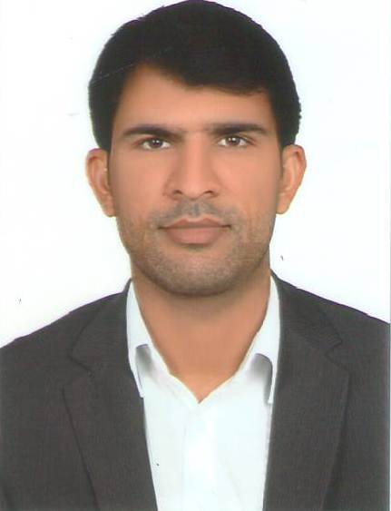
Engr. Irfan
Irfan.372277@2freemail.com

Personal Information:

Date of Birth 20-03-1988
Gender Male
Religion Islam
Marital Status Married
Nationality Pakistani

Educational Qualifications

BSc (Hons) Agri. Entomology (2006-2010) Gomal University D.I. Khan Pakistan

FSc (2004 - 2006) F.G Degree College Okara Cantt

Matric (2004) FBISE, Pakistan

Experience:

- Agriculture Engineer (Dec 2016 to still onward) in Burj Alasala Pest Control and cleaning services
•Using various pest control techniques ( IPM).
•Pest Control Operations.
•Termites Control.
•Managing Cleaning Operations
•Managing Manpower and their trainings regarding Health safety and Environment.
•Implementation of company policies.
- Agriculture Engineer( Aug 2015 to Nov 2016) in Trust Pest Control and cleanings Abu Dhabi
- Using various pest control techniques ( IPM).
- Pest Control Operations.
- Managing Cleaning Operations
- Managing Manpower and their trainings regarding Health safety and Environment.
- Area Manager (2013-2015) in ICI Pakistan Limited in Depalpur, Pakistan.
- Making new policies regarding Agriculture products
- Use of various Pest control methods(IPM)
- Management of vegetable crops(potato, cucumber and others tunnel farming)
- Land fertility and fertilizer Application
- Managing large orchards and gardens
- Marketing and account management
- Development of new markets to develop the business.

- Territory Manager (2011-2013) in Four Brothers Group of Pakistan.
- Use of various Pest control methods
- Management of cash crops (Wheat, Maize, Rice and cotton etc.)
                - Management of vegetable crops (Chilies, Onion, Cucumber, and Potato etc.)
                - Land fertility and pest control of crops
- Trainee (2010-2011)

      - Maize crop in MMRI Sahiwal Pakistan

      - Development of new varieties of Maize crop.

- Management of maize crop.
Trainings:
Participated in various trainings including:
- One Day Workshop on Water / Energy Conservation in Agriculture.
- One Day Workshop under Four Brothers Group of Pakistan.
- One Day Workshop “Farmer meeting effectiveness workshop”
- One Day Workshop “Basic selling skills”

Skills:
I have set of excellent skills and abilities to:
- Pest control techniques (Integrated pest management)
- Realize the field problems and solve them on scientific basis
- Manage a team work skillfully
- Create new ideas and Innovation for the development of work
- Manage Time effectively
- Manage the handling and operations of farm machinery
- Manage automatic irrigation systems for green houses
- Market agricultural materials and products
- Execute MS word, excel, and out look
Language:
Arabic, English , Urdu

