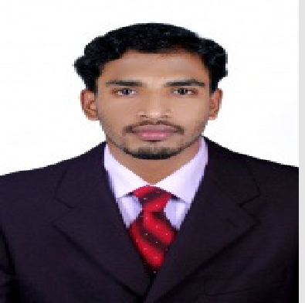VIPIN

Objective

Operate as a team player in a progressive and dynamic environment and prove myself by innovative ideas, learning abilities and hard work. Aim is to rise high and make notable contribution to my work assigned.

HAAD Details.

Application No : License No:

Academics

RADIOGRAPHY TECHNICIAN
VIPIN.372278@2freemail.com

Personal Profile:

Date of Birth: 01.10.1987 Age: 29 Yrs
Gender: Male Nationality: Indian Religion: Hinduism Marital Status: Married

DRT (Diploma in Radiological Technology)—August2008
Directorate of Medical Education-Government of Kerala AL-SHIFA COLLEGE OF PARAMEDICALSCIENCES
Perinthalmanna--Kerala

HSC (Higher Secondary Course- Plus Two)--March2005
Board of Higher Secondary Examination- Government of Kerala

SSLC(Board of public examination)- (March2003)
Secondary Education Board- Government of Kerala

Field of Interest
- X-Ray
- CTSCAN
- MRISCAN

Specialization

- X-Ray

- Computed Radiography, (Kodak CR classic , VITA and AGFA CR30-X system)
- 800mA High frequency machine, Siemens MedicalSystem
- 500mA and 300mA machine, GE MedicalSystems
- 500 mA machine, Philips MedicalSystems
- 300 mA machine, Siemens MedicalSystems
- Fluoroscopy&ImageIntensifierSystem–Adonis&Flurovision
- 60 mA & 100 mA Portable machines , GE &Vision MedicalSystems

MRI
- SIEMENSE (AVANTO 1.5Tesla)

CT
  - GE Health care (Hi speed Dual)

Job Responsibilities
    - Perform all radiography related works in Conventional Radiography, Computed Radiography, Cross sectional (CT and MRI) and Interventional radiological procedures (FNAC &Biopsy).
    - Skilled in Accident and Emergency Radiography.
    - Assist the organization in meeting the relevant regulatory requirements (X-ray, MRI & CT installation).
    - Implement all radiation surveillance measures, conduct periodic radiation protection surveys, maintain proper records of periodic quality assurance tests and personnel doses, instruct all workers on relevant safety measures, educate and train new entrants and take local measures including issuance of clear administrative instructions in writing to deal with radiation emergencies.
    - To ensure that all radiation measuring and monitoring instruments in my custody are properly calibrated and maintained in good condition. Suitable records of such surveys including layout drawings, dose mappings, and deficiencies noticed and remedial actions taken shall be maintained for future followup.
    - Preparing and dispatching monthly reports of radiology department including statistics, safety and quality issues to the Medical superintendent/ Chief Administrator.
    - To impart training to junior colleagues in Radiography, radiation safety and patient care.
    - Responsible for implementation and maintenance of quality controlprogram.
    - Maintenance of registers /records works.
    - Care of equipments and materials.

Job Description
    - Supervised in all department activities.
    - Supporting Inspection related work (MCI, FANR and HAAD).
    - Carried out Radiation Safety rules: As per the rule of AERB, Government of India and FANR Government of UAE.

General Radiography
    - Routine X- Rays, severe trauma, minor trauma, Ward Radiography cases and special procedures such as Intravenous Urography (IVU), Retrograde Urethrography, Micturating Cysto Urethrography (MCU), Cholangiography, Sialogram, Fistulogram, Static cystogram and Barium studies (Swallow, Meal, Enema).

CT scan
    - Routine CT cases, Contrast Procedure, Cisternogram for CSF Rhinorrhea, Cancer related test like as FNAC/Biopsies, and Retrospective Reconstruction of bones. Experience in Virtual Bronchoscopy, VirtualColonoscopy, Virtual Vasculoscopy and Volume Rendering processing such as 3D reconstruction
MRI scan
    - Routine MRI cases, Contrast Procedure, Angiogram, Perfusion & DTI

Employment History 8 Years, 10 Months Experience

- At present working : New National Medical Centre L.LC, Abu Dhabi
- Designation : Radiography Technician /
Radiological Protection Officer

- Joining Date : 05.11.2016

- Date left : Continuing

- Year of Experience : 1 year and 10 months.

- Previous Institution name: MES Medical College Hospital, Kerala, India

- Designation : Radiographer In charge/Supervisor
Radiological Safety Officer

- Joining Date : 18.02.2009

- Date left : 28.10.2015

- Year of Experience : 6 years and 8 months

Languages Known

- Languages can speak : English. Hindi and Malayalam
- Languages can read and write: English, Hindi and Malayalam

Conclusion & Declaration

I do here by declare that the above furnished information given by me is true and correct to the best of my knowledge and belief. I also assure you of complete dedication and hard work towards the organization.

VIPIN

