Curriculum Vitae
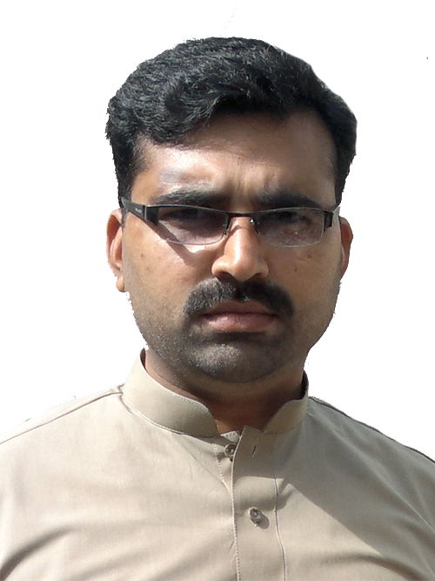  RESUME  SYED  SYED.372284@2freemail.com | MCS  (MASTER OF COMPUTER SCIENCES)

Career Objectives
A challenging position with an expanding and dynamic organization where I can implement skills that I have learnt through my education and experience and as well as enhance my knowledge by way of dedication and hard work.
Personal Details
- Country of Stay: U.A.E | - Country of Residence: PAKISTAN
- Date of Birth:01/11/1983
- Languages:  - English: Second Spoken Language  - Arabic: Excellent Level  - Urdu: Native Language | - Prefer Interview Language: English  Religious: Muslim  .

Academic Qualification
- Degree: Master of Computer Sciences (MCS) (2011)
University: Punjab University, Lahore, PAKISTAN
Grade/CGPA: 3.21/4.00 (80%) A Grade
- Degree: Bachelor of Computer Sciences(B.CS) (2008)
University: Punjab University, Lahore, PAKISTAN
Post Qualification Experience
- May. 2015 – Till Date
Desigination: Working as Purchase Representative and Data Entry.
Organization: RAMEZ GROUP, U.A.E
Tasks Performing
                - Making and releasing purchase Orders.
                - Maintain the stock in all branches.
                - Check the prices.
                - Cross investigating between different markets.
                - Dealing with different suppliers.
                - Dealing with Cosmetics & Detergents also food Stuff.

- Nov. 2012 – Aug.2014
Desigination: Worked as an I.T Manager & Assistant to C.E.O
Organization: ANWAR AL MASTAQBAL CO. (HYUNDAI Motors LIBYA)
Tasks Performing
                - Assist to C.E.O in different meetings.
                - Working on website building
                - Maintenance of computers
                - Networking
                - Installation of software & troubleshooting of computers
                - Finalizing the purchase orders of cars till delivery.
                - Installation of security cameras
                - Installation of security alarms & security gates
                - Designing pan flexes& booklets
- July 2012 – Nov. 2012
Desigination: Worked as an I.T Officer
Organization: TOYOTA MOTORS (Libya)
Tasks Performed
                - Working on website building.
                - Maintenance of computers.
                - Networking
                - Installation of software & troubleshooting of computers
                - Finalizing the purchase orders of cars till delivery.
- September 2010 – May 2012
Desigination: Worked as an I.T In charge
Organization: Minhaj-ul-Hussain University Lahore, PAKISTAN
Tasks Performed
                - Complete management and take care of computer labs.
                - Publicity advising.
                - Maintenance of computers both Hardware & Software.
                - Composing books & literature for public acknowledgment.
                - Design website and its maintenance.

Pre-Graducation Experience
May 2008 – June 2010
Desigination: Worked as an Administrator
Organization: Mashhad University, ISLAMIC REPUBLIC OF IRAN
Tasks Performed
                - Training of students about P.C networking in English
                - Computer Lab In charge at School & College
                - Making websites for different companies
                - Participating from Pakistani students delegation in Iran
IT Skills
- Microsoft Office (Excel, Power Point, Word & Publisher).
- Managing Microsoft Windows OS, DOS & Troubleshooting.
- Diploma in Microsoft Office Management and Internet.
- Diploma in Computer Hardware & Maintenance.
- Total Networks Management, Adobe Photoshop & Coral Draw, Web designing, web management.
Key Skills:
- Hard worker | - Team Player | - Problem Solver
- Dynamic | - Highly Qualified | - Reliable
Interests:
- Operations | - Customer Care | - Research | - I.T Services
References:
Will be furnished on request

