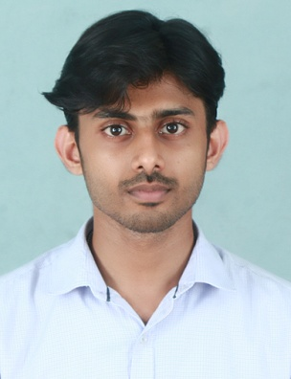
EXPERIENCE
Mechanical Engineer
MEP Engineer (Design),Airframe Aerodesigns Pvt Ltd, Cochin (2016 June – June 2017).
Projects Done
- HVAC design and drafting for residential building (G+2).
- Plumbing design for residential building.(G+2)
Jefin
Jefin.372302@2freemail.com
Gender : Male
Citizenship : Indian
Date of Birth : 03-06-1993
Marital Status : Single
Skills
HVAC,Plumbing,Electrical AutoCad,Revit,Duct Design,Piping,Fire Fighting, Heat Load Calculation.
- Heat load calculation and duct sizing for a hospital in Hyderabad.
- Prepared isometric drawings (chilled water lines) for Dubai Trade Centre District Cooling system.
- ESP calculation for a Labour Accommodation (G+4+R) in Dubai Investment Park.
- Done Stress analysis for chilled water and firefighting lines for Marsa Al Seef, Dubai.
- Done Stress analysis for buried chilled water lines for Jumeirah Village Circle and Jumeirah Village Triangle, Dubai.

Mechanical Engineer Trainee At Diwan Al Emara Doha, Qatar. (Dec 2015-March 2016)
Projects Done
- Private residence (YOUSAF KAMAL VILLA) in Doha using VRF (variable refrigerant flow).
- HVAC design of a palace (SHEIKH MOHAMED BIN FAISAL AL THANI) in Garrafa, Doha using roof top packaged units.
- Duct sizing and ducting layout of mosque in Doha.
- Prepared equipment schedule for private villa.

Hvac Trainee At Taiba Engineering Consultants. (Aug 2015-Oct 2015)

- Undergone 3 months training in HVAC and Firefighting, Designing and Drafting.
- HVAC design and shop drawing for an Apartment in Kochi (G+11).

Languages Known
- English
- Malayalam
- Hindi
- Tamil

Certification Courses
- Diploma in HVAC and Fire Fighting Designing and Drafting.
- Certified course in AUTO CAD.

OTHER WORKS
- Done electrical design calculation work for Atelier Ten Environmental Design consultants,Doha.
- Heat load calculations using HAP software and by manual methods for YOUSAF KAMAL VILLA, SHEIKH MOHAMED PALACE etc.
- Car parking ventilation for SHEIKH MOHAMED PALACE.
- FM200 calculation for firefighting.
- Stairwell pressurization calculation for SERVICE APARTMENT (2B+G+52FLOOR).

EDUCATION
- B.TECH in Mechanical Engineering from M.G University with 7.26 CGPA (AUG2011-JULY 2015)
- 12th from Jawahar Navodaya Vidyalaya Idukki with 86%.
- 10th from Jawahar Navodaya Vidyalaya Idukki with 92%.

PROFESSIONAL STRENGTH
- Capable of planning HVAC & Plumbing system design and can also be part of project implementation.
- Preparation and submittal of shop drawings (Auto Cad) and participate actively in the design and estimation of projects.
- Preparation and submittal of shop drawings (Auto Cad) and participate actively in the design and estimation of projects.
- Excellent command over Duct Designing methods and Heat Load Calculation(Manually by E-20 & General) and by software program – HAP(Hourly Analysis Program).
- Highly motivated and hardworking with the ability to work efficiently in a team as well as independently.
- Ability to communicate with others and to assimilate and understand information, in a manner consistent with the essential job functions.

DECLARATION
I hereby declare that all the information provided are true to best of my knowledge and belief.

