VIGNESH – SITE ENGINEER
VIGNESH.372316@2freemail.com

Objective

To work in an extremely challenging environment where I can fully utilize my problem solving and troubleshooting skills , efficiently facilitating growth of the organization and to grow with it.

Experience Summary

Nov 2013– May2016:

Designer/Project Engineer in Cladtech International LLC - Ras al Khaimah

CTI is a curtain wall expert, under the Al Rajhi Holding, a distinguished building solution firm. CTI provides a wide range of curtain wall solution for projects within the UAE, Europe and other GCC countries.

Work Description:

As a Design cum Project Engineer , I hold the responsibility to design and draft facades curtain walls and provide for structural posibilities which after approval will proceed for fabrication. When delivered at site assist them in installing by providing the detail drawings. Further assistance in solving technical issues when complications occur

Duties and Responsibilities

- Expertise in Aluminum Facades for Unitized curtain wall System, Stick Curtain wall system, Spider glazing system, Aluminum Composite panel Cladding, Doors & Windows.

- Preparation of Material Submittal and coordination with client / Consultant for approval.

- Tracking the project schedule and planning for all design related activities.

- Preparing total Bill of material & Quantity take off for the project purchase & procurement

- Preparation of schedule and fabrication detailing and shop drawings for projects based on the information and instruction provided

List of Projects worked so far with Cladtech International.

 | S.No |  |  | Name of Project |  |  | Area |  |  | Project Value |  |  | Role of Project
 | 1 |  |  | Prince Mohammad bin |  |  | Saudi Arabia |  |  | 130 Million Aed |  |  | Designer of steel and
 |  |  |  | Abdulaziz International |  |  |  |  |  |  |  |  | facades
 |  |  |  | Airport
 | 2 |  |  | Yas mall |  |  | Abu dhabi UAE |  |  | 90 Million Aed |  |  | Desinger of substructure for
 |  |  |  |  |  |  |  |  |  |  |  |  | Cladding works
 |  |  |  |  |  |  |  |  |  |  |  |  | Designer/Proj.Engineer of
 | 3 |  |  | Damac Lotus tower |  |  | Dubai Uae |  |  | 120 Million Aed |  |  | facade &
 |  |  |  |  |  |  |  |  |  |  |  |  | cladding

Alubond Middle East, June 2016 – Present

The World’s Largest ACP Brand with a twenty five million square meters of manufacturing and processing capacity which also is a pioneer in producing Highly Fire rated A2 mineral core panels.

Work Description:

Site Engineer will be the responsible to check, monitor & resolve all the issues of the project by coordinating with the corresponding departments like Design, Operation, Shipping & Installation until the job Handover to the customer.

Duties and Responsibilities

- Preparing the detailed schedule for the project in MS Excel.

- Making site survey and issuing the report to consultant for changes/modifications if required.

- Checking the availability of raw materials by comparing with BOQ .

- Attending customer meeting in case of Major changes has to make on the project after/during the installation to make best solutions acceptable to all parties involved to attain customer requirement.

- Raising the inspection request to consultant for several stages of installation & preparing the documents as per the comments provided by consultant if any.

- Coordinating with Purchase & Production department for all projects for pushing the materials to delivery.

List of Projects worked so far with Alubond Middle East

 | S.No |  |  | Name of Project |  |  | Area |  |  | Project Value |  |  | Role Performed
 | 1 |  |  | The Address hotel, |  |  | Dubai UAE |  |  | 16 Million Aed
 |  |  |  | Downtown
 | 2 |  |  | Majestine Hotel |  |  | Dubai UAE |  |  | 4 Million Aed
 |  |  |  | Apartments |  |  |  |  |  |  |  |  | Site Engineer for the
 | 3 |  |  | Clinique Farah |  |  | Ivory Coast |  |  | 351000 US
 |  |  |  |  |  |  | AFRICA |  |  | Dollars |  |  | installation of cladding
 | 4 |  |  | SAL Consultant |  |  | Ghana AFRICA |  |  | 1.8 Million GHC
 | 5 |  |  | EARL beam |  |  | Ghana AFRICA |  |  | 2.5 Million GHC

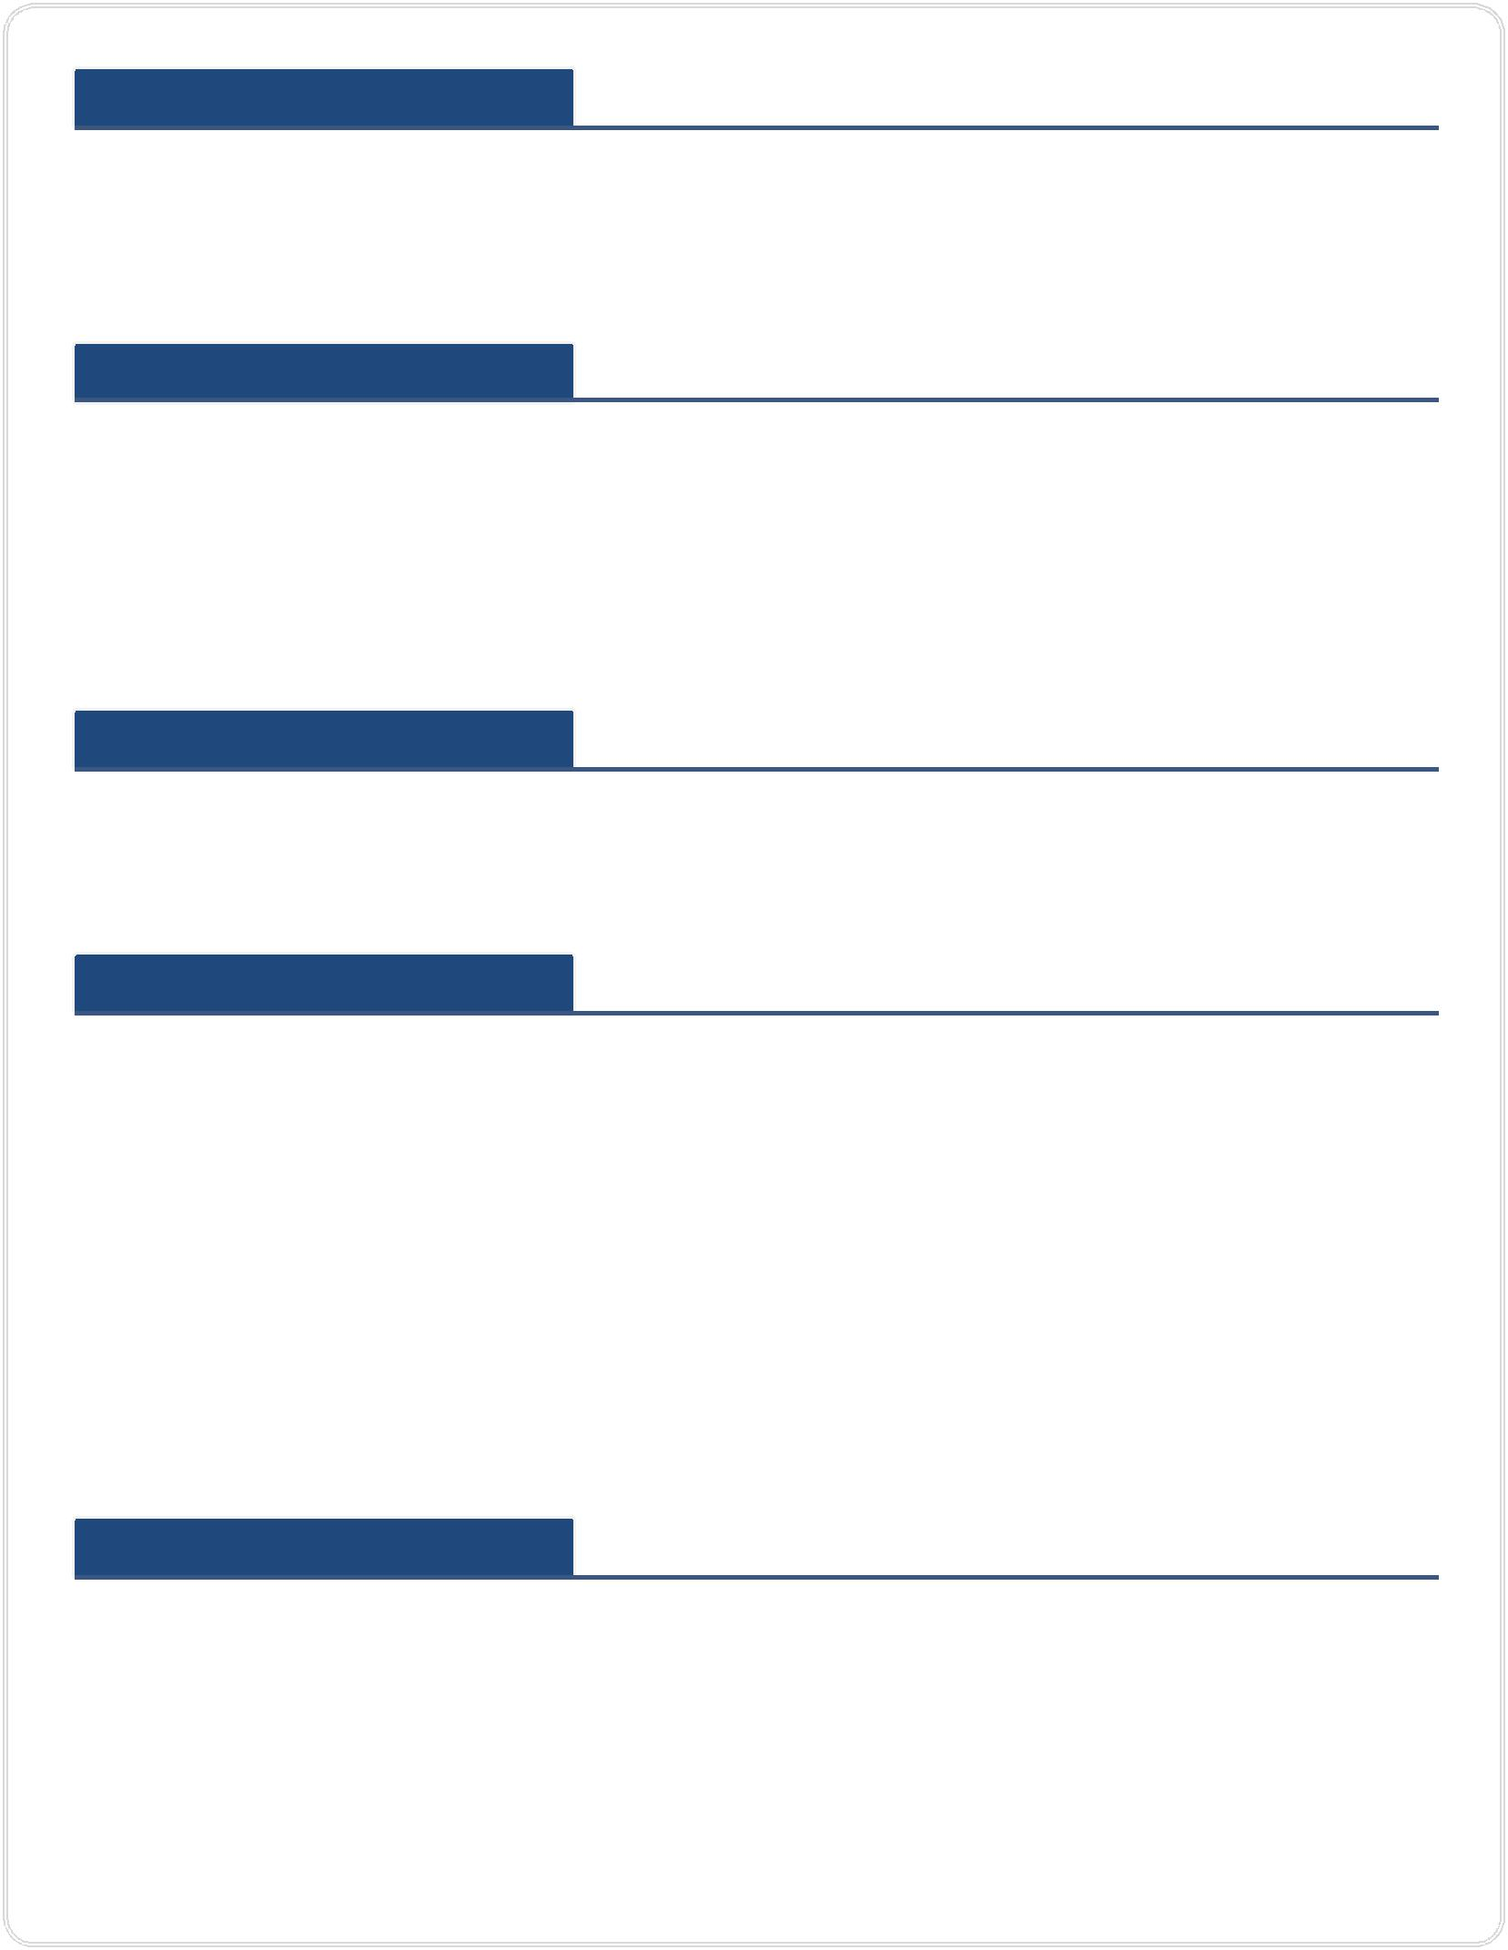Software Skills

- AutoCAD (Drafting)

- MS Office (Fab order , Material List , Component List)

- Solid works (Basic Knowledge for 3d visualisation)

- Plan IQ (For optimization of materials)

Educational Qualification

Bachelor of Engineering at Anna University in Chennai from 2008 to 2012 Grade : 6.5 CGPA

HSC at KAMAK Matriculation Higher Secondary School in Thoothukudi from 2007-2008 Grade : 88.9%

SSLC at Bharathiyar Vidhyalayam Higher Secondary School in Thoothukudi from 2005-2006 Grade : 83.2%

Language Skills

Tamil , English , Hindi - Excellent command of both written and spoken

Personal Details

Blood Group : A1+ve

Date of Birth : 14-06-1991

Marital Status : Single

Nationality : Indian

I hereby declare that the above information furnished is true to the best of my knowledge. I assure that if I am given a chance, I will execute my work to the fullest satisfaction of the organization.

