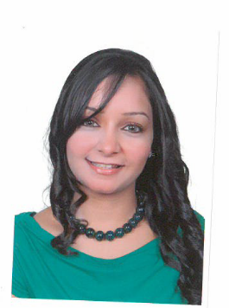
Nervana

Nervana.372330@2freemail.com

OBJECTIVE
To acquire a position in the field of communications or journalists as a content creator, copy writer, translator, or Public Relations specialist.

PERSONAL DATA
Date of Birth: September 14, 1990.
Place of Birth: Egypt.
Nationality: Egyptian.
Marital Status: Married.
Salary expectation: Not Specified/ Negotiable.
Visa Status: Husband Visa.

EDUCATION

Ahram Canadian University,2011

- Faculty of Mass Communication
- Major in TV & Radio and minor in Journalism
- General Graduation GPA: Very Good (B+)
- Graduation Project grade: A Awarded first place in the Graduation Project

EXPERIENCE

2010, Reporter in Al Ahram Newspapers-Cairo,Egypt
- Gathering information on current events
- Record audio of the conversation
- Write briefly all the data and submit it to journalist

2011, Accountant at Medcom Tours – CAIRO, EGYPT
- prepare finance balance sheets for every month
- Cash flow statements
- Prepare budgets
- Transfer checks to company account

2012, Manger Assistant at Artistic Touch Advertising Agency-cairo,Egypt
- organize schedule time, meetings and events-replying emails
- Content development of marketing collateral

2012,for one month Events Executive at M&M Events Company, CAIRO, EGYPT
- Co-ordinated large scale entertainment events
- Assist with site planning and confirming venues according to our budget
- Prepare the activates according to the age of audience
- Planning and time management

PROJECTS
  - Short movie about Slums in Al-Dawaka, Cairo, Egypt (2009)
Analyses suffering of the poor people in Dwaka
Shooting their homes

  - Press report about Procter & Gamble Company, Egypt (2010).
Ask the drivers about working day tack
Know what`s the reason of the a lot accident from the truck

  - Campaign about Early Marriage, Egypt (2010).
Talk to girls that married at 14 years old and know the reasons
Collect the data from Women`s rights that provide them the ratios in Egypt

  - Video report about Chinese Gold, Egypt (with editing) (2010).
Talk to the gold traders and the impact of Chinese gold about their own business

  - Video report about Traffic Problems, Egypt (with editing) (2011).
Make conversation with all kinds of drivers
Realize the reason the traffic laws and the bad infrastructure in Egypt

  - Award the 1st position in the Graduation project for Sectarian strife in Egypt (2011) Note: Find the link that Ahram Gate wrote about the film.

LANGUAGES
- Arabic Native
- English Excellent

PROFESSIONAL SKILLS

- Writing News (Short Stories)
- Ability to work under pressure
- Ability to work in a group or individually
- Dependable and conscientious - accurate at detail work. Attention to details
- Excellent customer service
- Culturally exposed to various nationalities.
- Excellent communication, interpersonal and organizational skills.
- Proficient in the use of Office applications (Word, Excel, PowerPoint).

