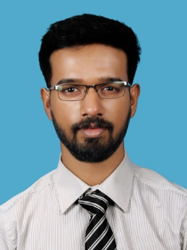
VIVEK
VIVEK.372335@2freemail.com

EDUCATIONAL QUALIFICATION:
Course | University/Board | Name of College/School | Mark | Year of Graduation
B.Tech  (Civil) | MG University | SNMIMT, Maliankara | 63% | 2017
AISSCE | CBSE | Amrita Vidyalayam  , Kodungallur | 67.6% | 2013
SSE | CBSE | Indian School Al-Ain, U.A.E | 9.2 CGPA | 2011

CAREER OBJECTIVE:
Seeking a challenging career in a well reputed firm where I can exploit my technical and soft skills; and my creativity towards making a significant contribution to the growth and welfare of the company and thereby myself.

INTERNSHIP:
- Company Name: Soma Enterprise Ltd
Project: Kochi Metro Rail Project
- Company Name: Cochin International Airport Ltd.
Project: New International Terminal

PERSONAL SKILLS:
- Possess versatility and spontaneity in the nature of work
- Punctual and honest
- Possess effective communication and interpersonal skills along with a hardworking attitude
- Ability to learn quickly and highly self-motivated
- Ability to lead and manage a team; and also be a motivation to the team

SOFTWARE SKILLS:
- Diploma in Computer Aided Design- AutoCAD 2D (Civil)
- Diploma in Office Automation- Microsoft Office

EXTRA CURRICULAR ACTIVITY:
- Member of organizing committee in college tech fest
- Member of National Service Scheme group at college
- Vice Captain - school student council
- Vice Captain - school scouts
- Bagged numerous medals for athletic events including 3 time school championship

MAIN PROJECT:
- Title: Smart Parking
- Analyse the various methods and strategies to be used for effective use of existing parking spaces in an already crowded city/town.

PERSONAL DETAILS:
- Name : Vivek
- Nationality : Indian
- Marital Status : Single
- Date of Birth : 19/02/1995
- Languages Known : English, Hindi, Malayalam
- Hobbies & Interests : Automotive Enthusiast, Pets

DECLARATION

I do hereby declare that the above information is true to the best of my knowledge.

