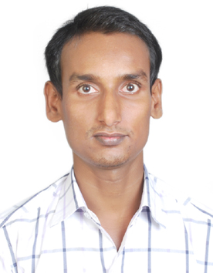

CURRICULUM VITAE

IMROJ
IMROJ.372358@2freemail.com
B.tech-ELECTRICAL & ELECTRONICS.
Position Applied for- junior electrical engineer.
Seeking a challenging position in a competitive work environment. wherein I can learn and implement my knowledge,experience and personal attributes to contribute to growth of the
Organization.

Professional Experience :-

Total Experience :- : 3 Years.

Gulf Experience :-

Name of company : Alshirawi Electical &Mechanical Engg.Co.LLC
Position : Electrical Foreman
Joining Date : 15 March 2016 to till date.
Project name : G+8 Residential building Nadd Hessa. Client : Team Engineering Ltd.
Consultant : Al Hashemi.

Indian Experience:-

Name of company : Roshan tech power Co.Pvt.ltd
Position. : Assistant Electrical site engineer.
Joining Date. : 5 July 2014.
Total Experience. : 1 Year 7 Month.
Project name. : Lodha Palava smart city Mumbai

Job Designation:-

- Responsible for work activity like,Slab conduiting, cable pulling,Db dressing, glanding and termination.
- Considerable knowledge of tray and trunking work routing.
- Considerable knowledge of fire Alarm,Emergency lighting system.
- Considerable knowledge of CCTV,Intercom Door access control system.
- Considerable knowledge of Data, Catv Smatv installation.
- Considerable knowledge of good coordination with Hvac, Plumbing,& Firefighting system.
- Considerable knowledge of transformer, switchgear, smdb, meter cabinet.
- Considerable knowledge of Load schedule and lighting system.
- Considerable knowledge of complex electrical control devices.
- Considerable knowledge of regarding Dewa inspection.
- Monitoring and prepare daily progress report and report to including supervision and monitoring site work.
- To regulate all the safety procedure during work process and according to safety procedure.

Academic Qualification

- Bachelor of Technology -ELECTRICAL & ELECTRONICS.
- From Jawaharlal Nehru Technological University (JNTUH), SMCET, Hyderabad, completed in 2014 with 73.81%.
- Intermediate (+2) science B.S.E.B, completed in 2010 with 64.60%.
- Matric (10th) from B.S.E.B, completed in 2008 with 77%

Key skills:-
- Technical ability in the field and in the office.
- Ability to organized and motivate a team or work equally well within one.
- Ability to work under pressure, stress and meet deadlines.
- Sound communication, interpersonal and negotiation skills.
- Self-motivated and fast learner, believe in achieving excellence through team work.

Additional skills:-
- Comfortable in computer language like C, C++ and also utility in MS office, Internet.

Declaration :-
I hereby declare that the particulars furnished above are true to the best of my knowledge and belief.

