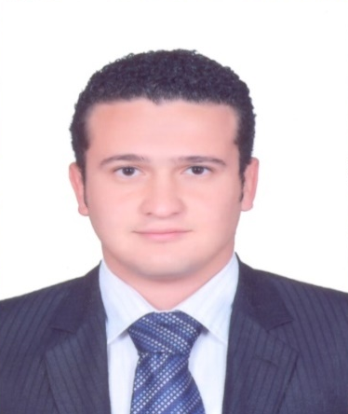
Samuel
U.A.E Dubai
Samuel.372375@2freemail.com

PERSONAL DETAILS

Date of Birth : 19th May 1990
Marital Status : Single
Nationality : Egyptian
Gender : Male
Military Service : Exempted

CAREER OBJECTIVE

- Seeking for a challenging Management Position at International Chain for Hotels and Resorts where my interpersonal skills and my experience can be applied and further developed. That will allow me to utilize my managerial, organizational, and leadership skills and to be able to deliver to the bottom-line. To constantly upgrade my knowledge and skills and make a difference in whatever I do.

ACADEMIC QUALIFICATION & TRAINING

- Bachelor of Tourism and Hotels
Department of Tour Guides 2007-2011
- Chinese Cultural Center in Cairo 4 levels in the Chinese language
- ICDL Compute 7 modules (Word-Excel-Access-I.T-PowerPoint –Windows-Net)
- Food &beverage skills training
- Food safety level 2
- CPR / First Aid
- Fire fighting

WORK EXPERIENCE

Designation : Acting F&B supervisor
Company : Sofitel Dubai downtown
Current job : 20th May 2015 till now
Job Responsibilities:
- To ensure prompt efficient service to our clients, and to assist the Food &Beverage Manager in his/her duties.
- To train staff to provide high standards of service and increase their personal knowledge.
- To assist the F&B Manager in the completion of ordering, scheduling and reports as necessary.
- To set an example of good grooming, punctuality, friendliness and knowledge.
- To ensure the work areas are clean and well maintained.
- To supervise all staff members in their duties and encourage or reprimand as necessary.
- To control costs as per budget and customer satisfaction.
- To maintain all F&B public and service areas in a clean and orderly condition.
- To deal with client concerns and complaints fairly and immediately.

Designation : Order taker In Room Dining
Company : The Oberoi Dubai
Duration : 5th of May2014 to 8thof May2015
Job Responsibilities:

- Accurately take Guest orders by means of Phone, ensure that Guest name, Room number, time of Guest order and Delivery timings are clearly registered. Follow established phone courtesy standards and actively sell food and beverage using up-selling techniques. Receive guest restaurant reservations and requests for “Private Dining Room” according to established hotel standards.
- Have full knowledge of all menu items, garnishes, contents and preparation methods
- Assists Room Service Server in preparing trays and carts.
- Responsible for issued banks, payments, change and accuracy of closed checks. Conduct shift end reports and forward them to the accounting department
- In absence of supervisor take the responsibility for shift in charge.
- Train new-Hires in service standards, menu items, up selling
Designation : Bartender & assistant captain
Company : Royal Savoy Hotel Sharm El Sheikh, Egypt
Duration :Aug.2012 to April 2014

Job Responsibilities :

- Mixing and serving alcoholic beverages to customers.
- Creating beverage lists, menus and drink promotions.
- Following all safety and sanitation policies when handling food and beverages.
- Upselling food and beverages to guests.
- Preparing cocktails and other drinks.
- Maintaining appropriate stock levels for the bar.
- Taking money from customers and process all card payments.
- Moving, lifting, carrying, pushing and pulling stock, chairs and tables around.
- Communicating with guests and making them feel appreciated.
- Maintaining the cleanliness of the bar area, as well as bar glasses and utensils.
Designation : waiter (F&B Services)
Company : Sierra Resort Sharm El Sheikh , Egypt
Duration : 3rd of Sep.2011 to 15th Of Aug 2012

Job Responsibilities
- Collect payment
- serve food or beverages
- provide customer service
- answer customer or public inquiries

LEISURE INTERESTS

- (Listening to music) (Travelling) (Playing Football)
STRENGTHS

- Well organized with a keen understanding of maintaining priorities
- Communication Skills and Feedback
- Professional Telephone Skills
- Cashier operations MICROS
- How to treatment with the guest complain
- Ability to work under pressure
- How to up selling to the guest
- Professional Telephone Skills
REFERENCES
- References available upon request

