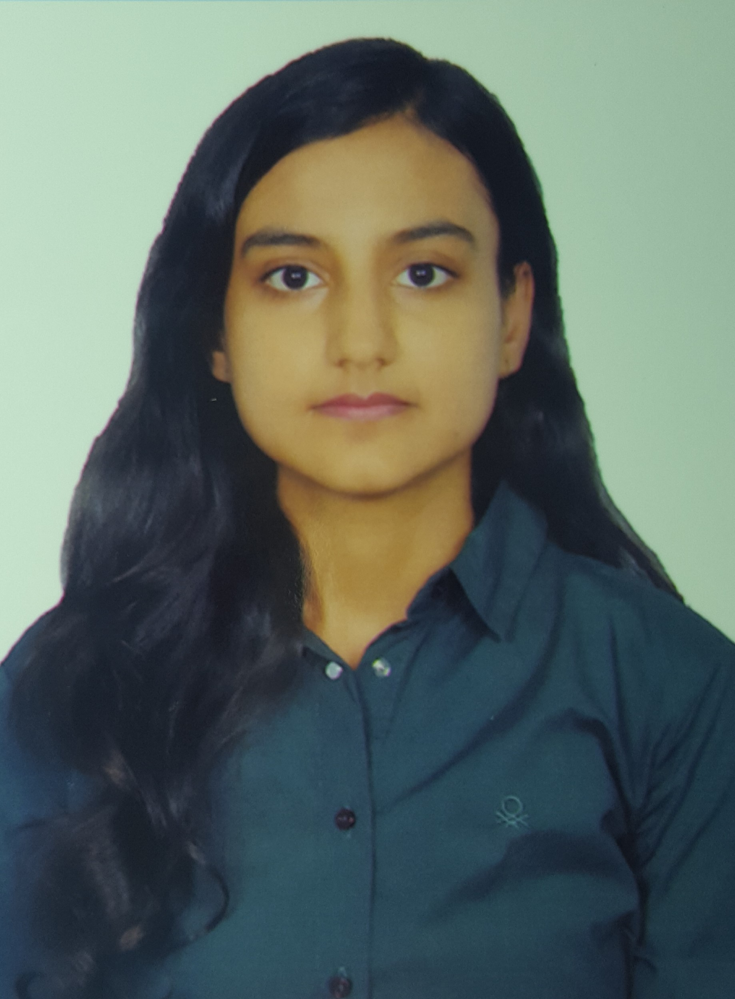

Pooja
Pooja.372396@2freemail.com

CAREER OBJECTIVE
To obtain challenging and responsible position in an organization leading to its successful growth using my abilities and knowledge.
EDUCATION
Completed M.com from MDS UNIEVERSITY in year 2017with 60%.
-Passed higher secondary in year 2014 with 76 %.
-Passed high school in year 2012 with 73 %.
TECHNICAL SKILLS
Skills ERP package Tally ( ERP9).
Windows, MS-Office (Word, Excel, PowerPoint), Internet.

EXTRA-CURRICULAR ACTIVITIES
Samsung Promoter ( Demo of product, explanation features etc).
Actively participated in various extracurricular activities in school as well as
Coordinated the events in college(2016).
qualified the common proficiency test 2015
WORK EXPERIENCE
worked as a consultant in L2C ltd jaipur,India from march 2017 to july 2017.
- Actively encourage new student to join.
- Store and update their data for organization's consideration.
- Tele calling, Negotiation
- consulting student for CA internship programs and seminar
HOBBIES

Travelling, painting, cooking, interacting people.

PERSONAL DETAILS
Date of Birth : 13th February , 1996
Marital Status : single
Languages Known : English, Hindi
Nationality : Indian
Visa Status : Visit valid till 21st september 2017

I hereby declare that all the information stated above is true and complete to the best of my knowledge and belief and nothing has been concealed / distorted.

Place:
Date:

