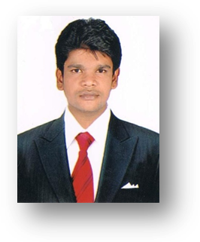
CURRICULAM VITAE

Ravi

Ravi.372398@2freemail.com
Objective:
Seeking a challenging position as an office Administrator / sales representative in a fast paced environment that will aid my career advancement.

Key Skills:
- Excellent Administrative & communication skills.
- Extremely bright academic records with absolute performance consistency.
- Quick Learner & Adoptability to Organizations requirements in line to boast healthy business activities.
- Thorough understanding of the fundamental principles of business administration and their practical usage.
- Highly organized thought process and well structured problem dealing attitude with an edge of innovativeness.
- High Command in Handling MS office tools and web search tools.
Experience
- Worked as a Asst Hr in IVRCL Ltd, Hyderabad from 15 July 2012 to 12 May 2014
- Worked as a Asst Hr. in Surasree Hotels and Resorts Pvt Ltd, Hyderabad from 05 July 2014 to till Date.
Educational Credentials
Post graduation:
M B A (Masters in Business Administration)
Specialization: Marketing Management & Human Resource Management
Academic year: 2009-2011.
Andhra University, Visakhapatnam, Andhra Pradesh, India.
Graduation:
B.Com computers
Academic year: 2004-2007,
Andhra university, Visakhapatnam, Andhra Pradesh, India.

Technical Skills:

Operating Systems : Windows7 / XP & Professional.
Office Tools : MS Word, MS Excel, MS Power Point, MS office.
Academic Project:
Delta Paper mills Pvt, Andhra Pradesh, India:
The methodology adopted to study the welfare amenities of Andhra Pradesh Paper Mills has been research oriented. The analyzed information has been collected from the HRD Officials of the Organization. And, the information collected from the employees and observations on employees working situations during the visits to various places of the Organization.

I hereby declare that the above mentioned information is true and correct to the best of my knowledge and I bear the responsibility for the correctness of the above-mentioned particulars.

