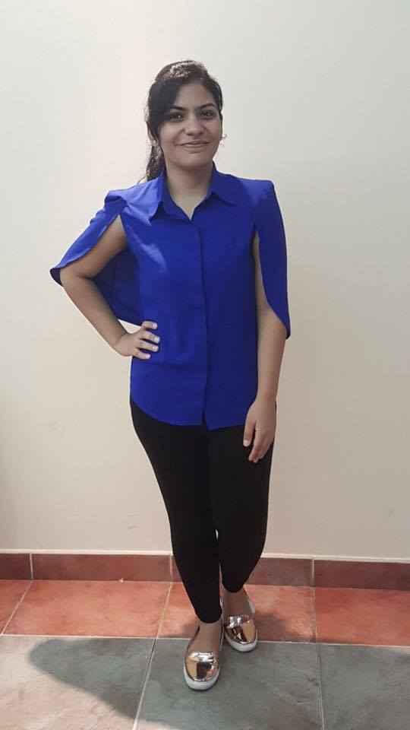

Punjabi

Hindi

English

**Fluent**

**Fluent**

**Intermediary**

**Languages**

Visa: Visit Visa (valid until Nov ’17)

Communication

Organisation

Teamwork

Planning

* Dean’s Merit List (Top 5% Students) in 2015
* Awarded 25% Academic Scholarship at the University of Wollongong in Dubai for outstanding performance
* Runner’s up at the Emirates Islamic Innovation Challenge in 2015 for creating one of the most innovative business proposal in Marketing & Finance
* Runner’s up at the UOWD Got Talent 2017 – Dance Category
* Winner of the Best Research Paper Presentation Award at the inter university Youth Earth Summit in 2014
* Commerce Stream Topper in high school CBSE 10+2 Exams with 94%
* Eduscan, Finance Intern (2017)
* Initiated a Master data Sheet aimed at simplifying the income recording system
* Responsible for preparing and analysing weekly Profit and loss reports and developing cost cutting solutions
* Assumed project lead on creating a weekly Google Ad words Financial Analysis Reporting system
* Emirates Islamic Bank, Intern (2016)
* Assumed project lead on researching the top fintechs and how they pose a threat to banks
* Worked with the channels team in the implementation of a new online banking system
* Trained and worked in various departments directly reporting to all the department heads
* Bachelors of commerce,

Major in Finance & Minor in International Business,

University of Wollongong in Dubai (WAM – 86%)

* CBSE (10+2):

DPS Dubai (Topper in Commerce with 94%)

* Expert in Microsoft Office( Word, Excel, Powerpoint)
* Sound knowledge of EIKON – Thomson Reuters Financial Software & Google AdWords

**Other Skills**

**Honours & Awards**

**Experience**

**Education**

Shravika

I’m a self-starter with a positive, can-do-attitude, driven by the urge to learn, improve and succeed. I currently seek to obtain a full-time position in the field of Finance that is offering opportunities for new professional and personal challenges. I believe these will allow me to learn new skills, grow professionally as well as allow me to help meet the goals of the organization through persistence and hard work.

**Career Objective**

**Skills**

Curriculum Vitae